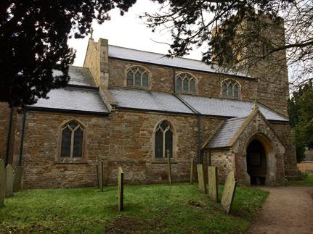

Saddington Parish Neighbourhood Plan

2018 - 2031
REFERENDUM VERSION

This page is intentionally left blank

Contents

 | Section Name | Page
 | Introduction from Chairman | 4
1 | Our Neighbourhood | 6
2 | What is a Neighbourhood Plan and Why is it Important? | 11
3 | Why We Need a Neighbourhood Plan in Saddington | 13
4 | How the Plan was Prepared | 14
5 | What We Want the Neighbourhood Plan to Achieve | 17
6 | Meeting the Requirement for Sustainable Development | 19
7 | Neighbourhood Plan Policies | 21
 | 7.1 Housing | 21
 | 7.2 Natural and Historical Environment | 33
 | 7.3 Community Facilities | 57
 | 7.4 Employment | 63
 | 7.5 Transport and Access | 69
8 | Community Actions | 73
9 | Neighbourhood Plan Policies | 75
10 | Monitoring and Review | 83
Appendices
1. Statement of Consultation
2. Basic Conditions Statement
3a. Saddington Census 2011 Profile
3b. Saddington Land Registry Data PPD 1995 to 2015
4. Housing Needs Assessment
5. Housing site assessment process
6. Environmental Inventory
7. Local Green Space Descriptions
8. Important Views Assessment
9. Local Heritage List Descriptions
Document filename: 0 Saddington Parish Neighbourhood Plan Referendum version 27 10 18.docx

Introduction from the Chairman of Saddington Neighbourhood Forum
It gives me great pleasure to introduce the Saddington Parish Neighbourhood Plan and see it reach this major milestone when we formally submit it for Referendum.
The Neighbourhood Plan is a new type of plan for the local area which has been drawn up by a Management Committee of volunteers from the parish and in response to your input over the last two years. It is very much Your Plan for Your Village helping to shape Your Future.
It’s a Plan that looks forward optimistically and lays out policies and proposals for the management of future growth and development of Saddington whilst ensuring that our heritage and unique environment continues to be protected over the period 2018-2031.
Our vision for Saddington is as follows:
Saddington is a small and peaceful village whose character is founded on its rural agricultural heritage, location, community identity and activities. It is surrounded by hedged agricultural land and wide views of particularly attractive countryside that are enjoyed by both residents and visitors.
Our vision for the next 15 years is for new development proposals to be shaped in such a way that Saddington manages its independent rural identity and locality, distinct from adjacent settlements.
The essential parts of this vision statement are to ensure that:
- Land use and development activity are consistent with and reflect the essential character of the Village and its conservation area, with due consideration to Local Authority guidance.
- Traffic and parking issues are managed to ensure the safety of residents, pedestrians, cyclists, horse riders, walkers and motorists.
- Local employment within existing and new suitable businesses and working farms is encouraged.
- The natural environmental diversity and the sense of tranquillity and open spaces are managed by the protection of Green Areas, both within the Village and the wider parish, and the separation from surrounding Villages.
- The strong sense of community spirit and cohesion is fostered.

It is important to note that having a Neighbourhood Plan does not mean that development will not happen. Development will still take place, but with consideration to the policies in this Plan, which set out the conditions for the type of sustainable development that local people have agreed is in keeping with our area’s character. However, without a Neighbourhood Plan, decisions would instead be based on the District and National policies rather than locally formulated criteria.
We are grateful to Officers at Harborough District Council and the wider community for their involvement in the development of the Neighbourhood Plan. Residents of Saddington are rightly proud of our community and wish to see it grow appropriately and sensitively in the coming years. This Neighbourhood Plan seeks to achieve that ambition.
Chris Carter, Chairman
Saddington Parish Neighbourhood Forum, October 2018

Our Neighbourhood

History

Saddington is a small hilltop village overlooking open countryside and Saddington Reservoir which was constructed between 1793 - 1797 to feed the Grand Union Canal which crosses the parish and passes through the historic Saddington Tunnel. The village lies about mid-way between the A6 and A5199 main roads. It is separated by beautiful open countryside from the much larger settlements of Fleckney, about 1 mile to the north, and Kibworth, about 2 miles to the west. The open countryside that maintains Saddington’s distinctive and separate rural character is mainly used as agricultural land.

Most of the houses that comprise the compact village of Saddington are of red brick and range in date from the early 19th century to the present day. Among the smaller and older buildings mud walling survives, and there is one timber-framed cottage.

Saddington had a recorded population of 33 in 1086. The poll tax was paid by 135 people in 1377. There were 23 households in 1563 and 110 communicants in 1603. There had been some increase by the late 17th century: 47 households existed in 1670, and 144 communicants were returned in 1676. There were 45 households in the early 18th century. In 1801 the population was 241; it rose to a maximum of 279 in 1841, had fallen to 182 by 1891, and recovered to 243 in 1901. In 1951 it was 190.

Saddington was Enclosed in 1770 by Act of Parliament. A notable physical change took place in Saddington with the construction of the reservoir between about 1793 and 1797. This acted as a catchment basin for the supply of water to the Grand Union Canal. A natural hollow was banked at its northern end and held water from the Laughton and Saddington brooks. Feeders were constructed to carry the water from Saddington Brook to the reservoir and from the reservoir to the canal. The reservoir occupies about 24 hectares wholly in Saddington parish.

Saddington has always been mainly an agricultural village, with a few people employed in the usual village handicrafts and trades. The parish has remained chiefly under pasture since the Enclosure.

The following section describes Saddington today and helps to establish the context for the Neighbourhood Plan policies including those related to housing and employment.

Saddington today

In 2017 there are 196 persons on the Electoral Register for Saddington Parish.

According to the 2011 Census (see Appendix 3) the Saddington parish had an estimated population of 309 residents living in 100 households dispersed across 709 hectares. There were 11 vacant dwellings representing a 10% vacancy rate. At the time of the Census the parish contained one communal establishment providing accommodation for 55 residents. Between 2001 and 2011 the number of residents living in the Parish increased by around 52 (+20.2%). The number of occupied households rose by 14 (16%) and the number of dwellings (occupied and vacant) went up by 20 (22%).

In 2011, around 13% of residents were aged under 16 which is somewhat lower than the district, regional and national (19%) averages whereas. Around 62% of residents were aged between 16 and 64 which is close to the district (63%), regional and national (65%) rates. Older people (aged 65+) represent over 25% of total residents which is above the district (18%), regional (17%) and national (16%) rates. This is partly due to the presence of a nursing home in the parish which provides residential care for the elderly. In 2011 the median age of people living in the parish was 48 which is older than the district (43), regional (40) and national (39) rates.

A more detailed breakdown of age bands reveals Saddington has a somewhat higher than average representation of people aged between 40 and 59 and those aged 80 and above. There is an under representation of 0 to 9-year olds and those aged between 20 and 39 when compared with the district, region and England as a whole.

Population by 10-year age bands, 2011
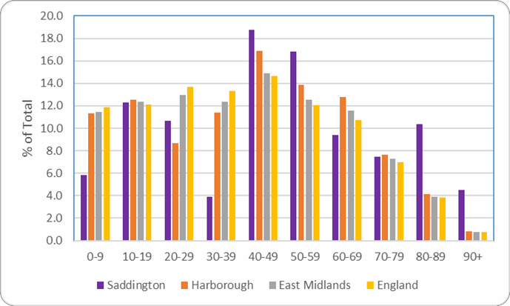

The Census provides further evidence of an ageing population as between 2001 and 2011 the number of residents aged 60 and over increased by 20% (+15). Research shows the number of older people will grow significantly in the future and relative growth will be highest in older cohorts. Latest available population projections suggest that Harborough’s 65 plus age group is forecast to grow by around 65% between 2014 and 2034.

At 75%, the percentage of economically active people in Saddington was higher than the district (74%), regional (69%) and national (70%) rates. At 16% the parish self-employment rate is somewhat higher than the district (13%), regional (9%) and national (10%) rates. At the time of the 2011 Census, the unemployment rate was very low.

At the time of the 2011 Census, the average household size in the Saddington Parish was 2.5 people which is higher than the regional (2.3%), district and national (2.4%) rates. The average number of rooms per household at 6.8 is higher than the district (6.3), regional (5.6) and national (5.4) rates.

People living in the Saddington Parish are also more likely to live in homes with a higher than usual number of bedrooms with the average number of bedrooms per household standing at
3.4 which is above the district (3.1), region (2.8) and national (2.7) rates.

Home ownership levels are relatively high with around 76% of households owning their homes outright or with a mortgage or loan. This is slightly lower than the district (78%) average but higher than both regional (67%) and national (63%) rates. Social rented properties account 12% of tenure which is higher than the district (8%) but lower than the region (16%) and England (18%) rates. Around 10% of households live in privately rented homes which is close to the district (11%) average but below the regional (15%) and England (17%) rates.

Data from the 2011 Census shows that over half (51%) of residential dwellings are detached which is higher than the district (48%), regional (32%) and national (22%) share. Semi- detached housing accounts for around 32% of residential housing stock compared with 29% for the district, 35% for the region and 30% for England as a whole. Detached and semi- detached represent 84% of the total housing stock in the Saddington Parish whereas terraced housing and flats provide 16% of accommodation spaces.

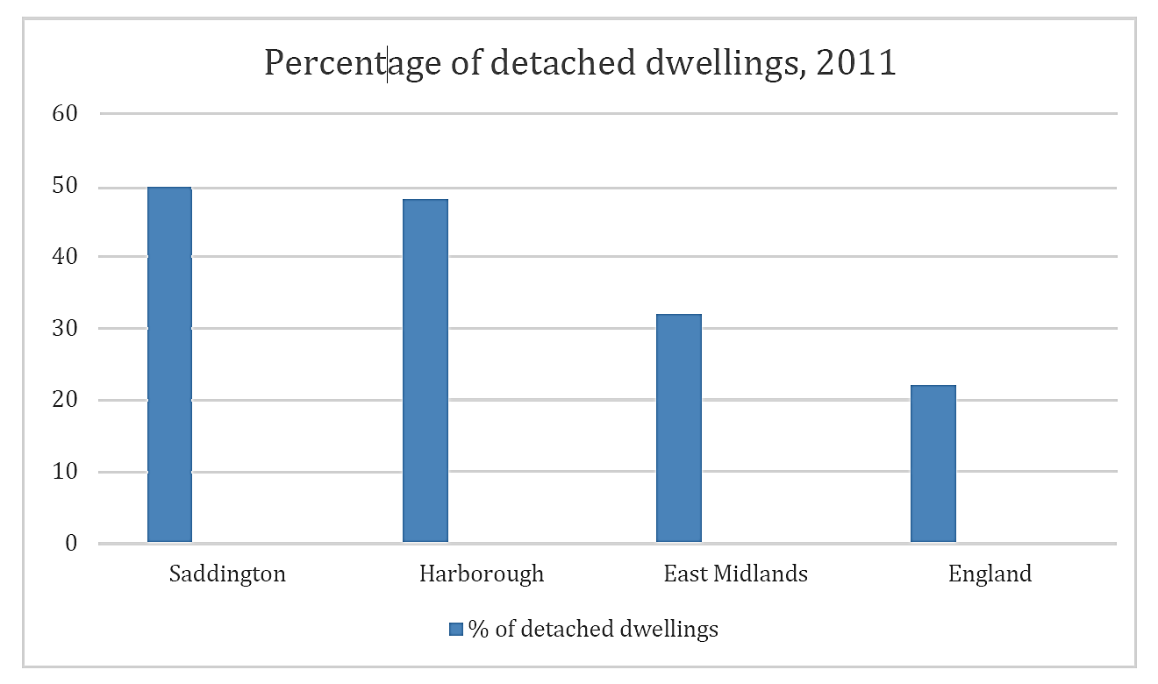

People living in the parish are more likely to be living in dwellings with 4 or more bedrooms. Results from the 2011 Census show that 46% of households live in housing with more than 4 bedrooms which is above the district (34%), regional (20%) and England (19%) averages. There is an under representation of housing for single people with just 3% of dwellings having one bedroom against 6% for the district, 8% for the region and 12% for England as a whole.
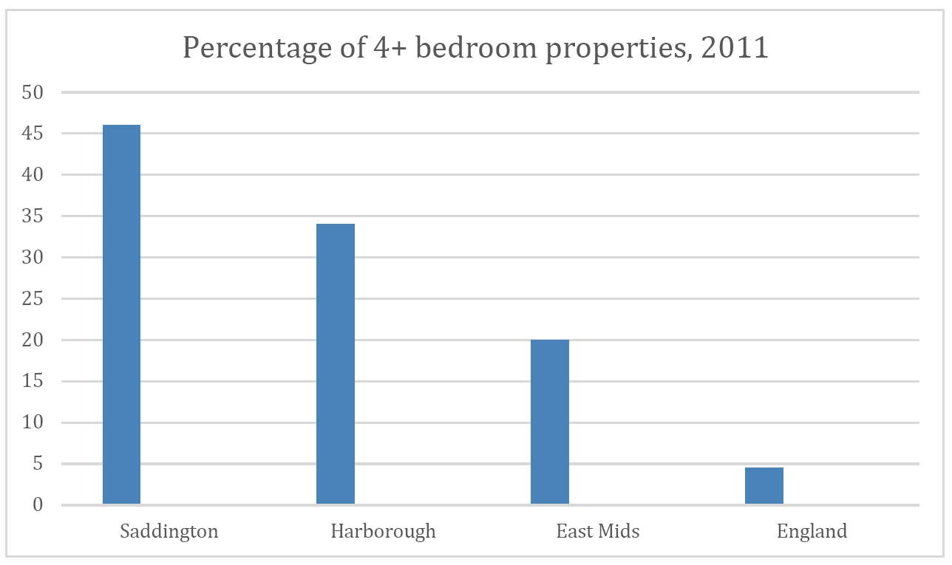
There is evidence of under occupancy in the parish (having more bedrooms than the notional number recommended by the bedroom standard). Analysis of the 2011 Census shows that more than a half (54%) of all households in the Saddington Parish have two or more spare bedrooms and around 30% have one spare bedroom. Under occupancy is higher than district, regional and national rates. Under occupancy is not unusual in rural areas because there is typically less social housing and a tendency for larger properties. Under occupancy is particularly evident in larger properties with around 48% of households with 4 or more bedrooms occupied by just one or two people.

Census data also suggests that on the whole older person households are more likely to under- occupy their dwellings. Data from the Census allows us to investigate this using the bedroom standard. In total, some 77% of pensioner households have an occupancy rating of +2 or more (meaning there are at least two more bedrooms that are technically required by the household) and is higher than the 49% non-pensioner household rate.

Overcrowding is not a significant issue in the parish, however, research shows that households with dependent children are more likely to be overcrowded. The Census implies there is some evidence of an extremely small number of families with dependent children living in overcrowded households in Saddington.

The Census implies there was a net change increase of 20 dwellings between 2001 and 2011 and there is evidence of a very small number (2) of new build homes being sold between 1995 and 2001. It should be noted, however, that the number of sales could be under recorded as there can be a time lag of new registrations entered onto Land Registry records. It should also be noted that not all new builds will be captured in the Land Registry price paid data, eg some conversions and social housing units will be excluded.

The publication of middle layer super output area (MSOA) level income estimates for 2011/12 presents an opportunity for detailed housing affordability analysis. In England and Wales in 2014, the average MSOA had an average house price equal to 380 times net weekly household income. The MSOA (E02005371) which covers the Saddington Parish was 350 times the net weekly household income which suggests it would be difficult for those on lower income such as first-time buyers to enter the current housing stock.

In the East Midlands, the lowest house price to income ratio was in Bolsover 003 MSOA where the average house price for all dwelling types was equal to 151 times the average net weekly income and the highest was the Derbyshire Dales 002 MSOA with 574 times

What is a Neighbourhood Plan and why is it Important?
A Neighbourhood Plan is an opportunity for local people to create a framework for delivering a sustainable future for the benefit of all who live, work or visit our area.

The right for communities to prepare Neighbourhood Plans was established through the Localism Act 2011 and the rules governing their preparation were published in 2012. The National Planning Policy Framework (NPPF) states that a Neighbourhood Plan gives the community “direct power to develop a shared vision for their neighbourhood and deliver the sustainable development they need” (NPPF para 183). It enables us to ensure we get the right types of development in the right locations; and to set planning policies that will be used in determining decisions on planning applications across the Parish.

A Neighbourhood Plan, once given statutory force, becomes part of the Development Plan for the area and this statutory status gives Neighbourhood Plans far more weight than other local documents such as parish plans or village design statements. However, a Plan must also comply with European and National legislation and be in general conformity with existing strategic planning policy. While every effort has been made to make the main body of this Plan easy to read and understand, the wording of the actual policies is necessarily more formal so that they comply with these statutory requirements.

Robust evidence is the foundation on which a Neighbourhood Plan has to be based. This includes evidence of community engagement and consultation and how the views, aspirations, wants and needs of local people have been taken into account alongside stakeholder comment and statistical information to justify the policies contained within the Plan. A detailed Statement of Consultation (Appendix 1) and a comprehensive Statement of Compliance with the Basic Conditions (Appendix 2) are available as Appendices.

This is the Neighbourhood Plan for Saddington Parish Neighbourhood Area, which covers the whole of Saddington Parish as shown on the map of the designated area in Figure 1.

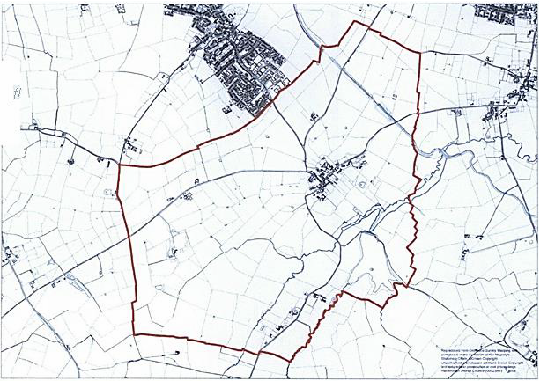
Figure 1: Saddington Neighbourhood Area – designated on 18 July 2016

Why we need a Neighbourhood Plan in Saddington Parish
The Parish Meeting has been very keen to influence planning matters within Saddington and to take the decisions locally that will serve the best interests of the community in the years to come.
There is recognition that limited sustainable development is acceptable, as without it our village will stagnate, but we want to influence and direct the shape and nature of the development and where, within our Neighbourhood Area, it takes place.
A Neighbourhood Plan cannot be used to prevent all development and we have been very clear from the outset that we will work within the broad housing requirements specified by Harborough District Council. Saddington is not required to accommodate significant development over the lifetime of the emerging Local Plan. Nonetheless, having a Neighbourhood Plan gives us the opportunity to identify the best ways to manage development, therefore directing it towards the areas that the local community needs and wants, and making sure that any new housing meets a locally identified need while protecting our natural environment and community assets and ensuring a sustainable future for ourselves and future generations.
Many issues of importance to the residents of Saddington have emerged through the consultation process and these have been tackled through the preparation of the Neighbourhood Plan. The protection of important environmental spaces; maintaining separation from adjacent villages; safeguarding important buildings; addressing concerns over traffic and transport issues; shaping economic development in the Parish and safeguarding important community facilities are all referenced and addressed within this document.
This Plan has been prepared by the ‘Saddington Parish Neighbourhood Forum’ that was designated by Harborough District Council in July 2016 as the Qualifying Body to create the Neighbourhood Plan for Saddington Parish with the support of members of the community with these goals in mind. We have embraced the NPPF’s core principle of “a presumption in favour of sustainable development” and have approached our task as a “creative exercise in finding ways to enhance and improve the places in which we live our lives” (NPPF paragraph 17). The Neighbourhood Forum will dissolve five years after its original designation, i.e. in July 2021.

How the Neighbourhood Plan was Prepared
This Neighbourhood Plan was prepared under the direction of Saddington Parish Neighbourhood Forum supported by Neighbourhood Planning consultants Yourlocale.
The Neighbourhood Forum Management Committee’s mandate was to drive the process, consult with the local community, gather evidence to support emerging policies and prepare the Plan. A detailed chronology of the approach to consultation and the outcomes is contained within the Consultation Statement that is included as appendix 1 of the Neighbourhood Plan.
A community questionnaire produced in the spring 2017 was completed by 45 residents of the Parish, and this helped to identify some of the key issues that would need to be addressed through the Neighbourhood Plan.
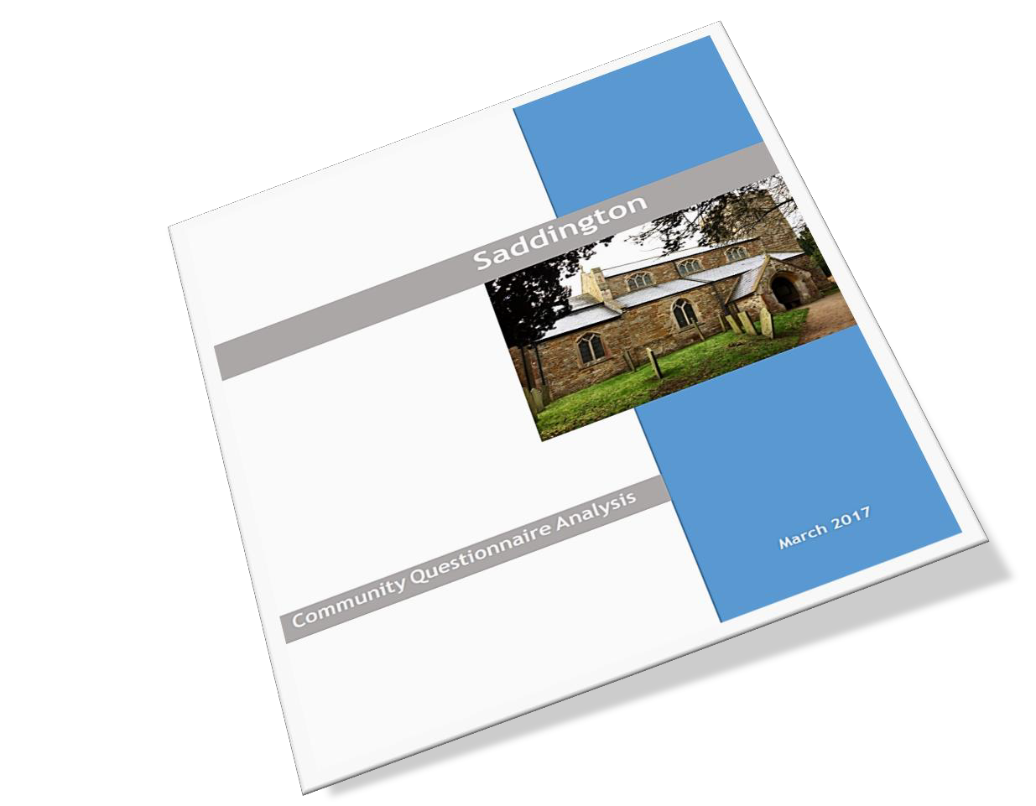
The Management Committee also gathered statistical information about the Parish from a range of sources to provide a body of evidence on which to base the Plan’s emerging Policies.
This was followed up with an Open Event in March 2017 that was attended by 44 people. This event offered an opportunity for people to understand what the Neighbourhood Plan was about and to offer thoughts about how Saddington might look in the years to come.
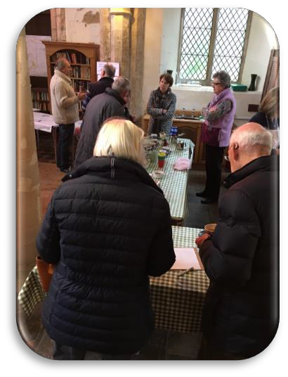
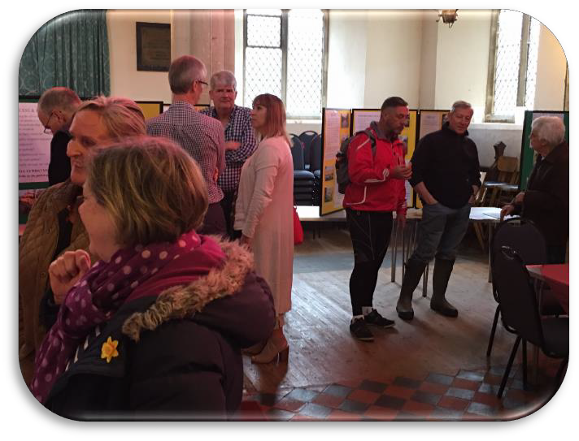
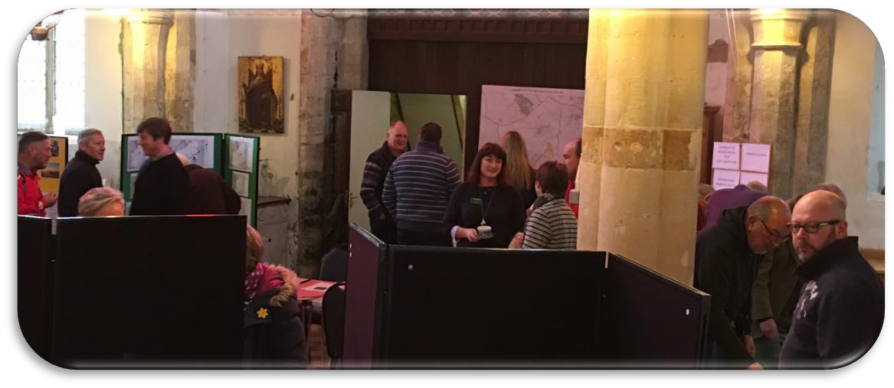
Images from the consultation event in March 2017
In June 2017, three ‘Theme Groups’ were formed of members of the Management Committee along with other residents and stakeholders. The groups met over the summer and early autumn 2017 and gathered the evidence needed to progress ideas and to formulate policies.
The Neighbourhood Plan was developed from these discussions, from all the other consultations and interviews conducted by members of the Management Committee and from research and evidence collected.
The draft policies were put to the community at a further consultation event held on 28 October 2017.

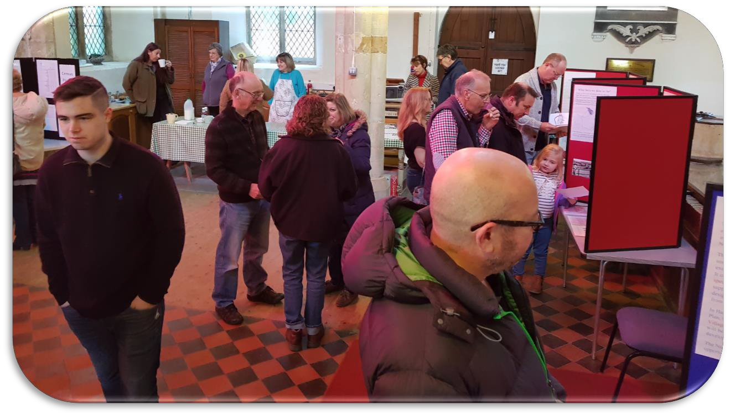
An image from the consultation event from October 2017
There was overwhelming support for the draft policies as reflected in the consultation analysis (see supporting information) and detailed in the Statement of Consultation (Appendix 1).
Throughout the Plan’s development we have liaised with Officers from Harborough District Council to ensure that emerging policies are not only in general conformity with the existing Core Strategy but also unlikely to conflict with policies being progressed in the emerging Local Plan, which is expected to be adopted in 2018.

What we want the Neighbourhood Plan to achieve
The Neighbourhood Area (i.e. the area that is addressed by this Neighbourhood Plan) encompasses the whole of the Parish of Saddington. The Neighbourhood Plan covers the period up to 2031, i.e. the same timescale as the new Local Plan for Harborough District Council. The Neighbourhood Plan is not intended to replace or supersede the Local Plan, but rather to sit alongside it, and to add additional or more detailed policies that are specific to Saddington. Where the Local Plan contains policies that already meet the needs and requirements of Saddington these are not repeated here. Instead, the Plan focuses on those planning issues which consultation shows matter most to the community, and to which the Neighbourhood Plan can provide the greatest additional value. It is important to note that when using the Neighbourhood Plan to form a view on a development proposal or a policy issue, the whole document and all the policies contained in this Neighbourhood Plan must be considered together.
When the Neighbourhood Plan is ‘Made’, it will become part of the Development Plan for the Harborough District. After being ‘Made’, each time a decision on a planning application relating to Saddington is taken by Harborough District Council or any other body they will be required to refer to the Neighbourhood Plan (alongside the District’s own Local Plan and other relevant documents) and check whether the proposed development is in accordance with the policies the community has developed.
This is the first time that communities have had the opportunity to create planning policies with this degree of statutory weight.
There are some restrictions to what Neighbourhood Plans can achieve. For example:
- They cannot promote less development than is set out in the Local Plan;
- They deal essentially with land use issues; they cannot address enforcement issues.
- While issues such as, for example, improvements to a bus route do not directly relate to land use issues, Neighbourhood Plans can encourage funding for these through developer contributions. Non-planning related issues such as this are addressed within the Neighbourhood Plan as issues for ‘community action’.
The Plan includes several elements, these include:
- Designation of Local Green Spaces, which identify and protect these special and locally important areas from development.
- Policies in relation to housing provision and need;
- The protection of important community assets;
- The incorporation of the design aspects into the Neighbourhood Plan;
- Protection of important buildings and structures and open spaces of local importance;
- Protecting businesses and supporting business expansion in appropriate locations; and
- Maintaining green spaces between adjacent villages.
- A simple and clear vision for the Plan based on local consultation, as stated in the introduction on page 4.
The Plan is a live document which will be kept under review and will change over time in response to new and changing needs and priorities.

Meeting the requirement for Sustainable Development
The NPPF states that there are three dimensions to sustainable development: social, environmental and economic, all of which are important and interrelated.

Social
We have sought, through the Neighbourhood Plan, to safeguard existing open space for the future enjoyment of residents.
We are also seeking to protect existing community facilities and to ensure that any new housing in the Parish reflects a mix of housing types that meets the needs of present and future generations of residents and ensures that we support the community’s needs and its health, social and cultural wellbeing.

Environment
In order to protect and enhance our natural, built and historic environment, we are seeking to ensure that:
- Housing development is of the right quantity and type in the right location, so that it does not harm but instead positively reflects the existing and historic character of the area;
- The most important open spaces within Saddington are protected from development, to protect the village identity and to retain the rural nature of its surroundings;
- Development recognises the need to protect and, where possible, improve biodiversity and important habitats; and
- Provision is made for improved pedestrian and cycling facilities.
- Development does not adversely affect car parking within the village.

Economy
Saddington is a small community which is primarily residential, but there is also a commercial and retail element within the Parish and a desire to ensure that appropriate economic activity is maintained as long as the local infrastructure supports it. We therefore wish to retain and encourage small scale employment opportunities in our area by:
- Protecting existing employment opportunities;
- Supporting small scale business development and expansion where the local infrastructure would not be adversely affected by the proposals; and
- Encouraging start-up businesses and home working.
This document sets out local considerations for achieving sustainable development within Saddington. Development proposals should meet the requirements of all relevant policies in this Neighbourhood Plan and be in general conformity with district-wide and national planning policies.

Neighbourhood Plan Policies

Housing and the Built Environment

Introduction
The village is of ancient origin and is mentioned in the Domesday Book when its population was 33. Its street plan reflects its ancient origins and there are a significant number of very high quality older properties. There remains a cluster of former working farms within the Parish which farmed the land spreading outwards from the village core. The parish church of St Helen’s is a grade two listed building dating from the 12th century.

Consultation
Consultation with the community about what, if any, development was preferred within the village was undertaken by questionnaire (February 2017) and a drop-in event (March 2017). The results revealed preferences for single plot infill development. Building on smaller sites received some support. There was less support for large scale development.
When asked what sort of housing was preferred if there was to be new development in the Parish, the response was (expressed as a percentage of the total responses):

Questionnaire findings

Type of Housing | Need a lot more | Need a few more | About right | Not needed
Eco housing | 31.7 | 21.9 | 24.4 | 21.9
Starter homes | 16.3 | 44.2 | 20.9 | 19.6
Individual design | 22.0 | 26.8 | 34.2 | 17.1
2-3 bed | 0 | 52.3 | 36.4 | 11.4
Bungalow or retired | 6.8 | 36.4 | 36.4 | 20.4
Private rented | 0 | 11.9 | 67.1 | 31.0
Social rented | 0 | 14.3 | 47.6 | 38.1
4 bed and over | 4.8 | 14.3 | 26.2 | 54.8
Flats | 0 | 2.4 | 11.9 | 85.7

The consultation results show that the village is not in favour of the provision of additional large properties. The preference is for smaller affordable properties suitable for first time buyers and retirees in numbers proportionate to the size and character of the village while recognising ecological concerns.

Housing Provision
As the draft Harborough Local Plan (July 2017) states ‘The full objectively assessed housing need for the Leicester and Leicestershire Housing Market Area is 4,829 dwellings per annum between 2011 and 2031 (96,580 total) and for Harborough District is 532 dwellings per annum between 2011 and 2031 (Housing and Economic Development Needs Assessment), giving a total plan requirement across the 20-year plan period of 10,640 dwellings’.
The draft Local Plan incorporates a 20% buffer and therefore makes provision for 12,800 dwellings from 2011 to 2031. Of this, 8,150 dwellings have already been built or committed (through the granting of planning permission, or through allocation in Neighbourhood Plans) leaving a residual requirement of 4,650 dwellings up to 2031.
Under the Adopted Harborough Core Strategy 2006 – 2028, Saddington is classified below the level of ‘Selected Rural Village’ where development is strictly controlled in order to protect the integrity of the landscape, the character and the settlement pattern.
Core Strategy policy CS1 describes the spatial strategy as being ‘to support rural housing which contributes to affordable housing where there is a need to protect existing services’. CS17 requires development in settlements such as Saddington which are classed as ‘Countryside’ to be strictly controlled and where there are identified Limits to Development (such as in Saddington) this should involve ‘very limited small-scale infill development’.
The draft Local Plan (July 2017) establishes a hierarchy of settlements to help to determine the most appropriate locations for development. On the basis of this hierarchy, it is proposed that Saddington is classified as an ‘Other Village or Rural Settlement’ which the draft Local Plan describes as ‘the least sustainable locations for growth and are covered by housing in the countryside policy. New housing will be limited to small sites to meet a locally identified need (either through a housing needs survey or Neighbourhood Plan), housing to meet the needs of a rural worker, isolated homes in the countryside in accordance with NPPF paragraph 55, and replacement dwellings’.
Through the Neighbourhood Plan, the opportunity has been taken positively to plan for development within Saddington to help meet local need and help to support local services. The Limits to Development have therefore been reinforced and updated in order to accommodate the potential for housing growth up to 2031 and to direct development to the most suitable locations.
This will enable the Parish to secure the growth that is recognised as being acceptable through windfall developments in locations favoured by the community, avoiding the uncertainty that comes with speculative development proposals that threaten the future character of the village.
After community consultation, there was a clear preference to keep the special nature of the village intact for future generations to enjoy. Any new sites and density of development will therefore be kept proportional to the size and character of the Parish. Devising a land use plan for residential development is an important element of the Neighbourhood Plan.
In progressing the Neighbourhood Plan, the Saddington Neighbourhood Plan Management Committee established 3 ‘Theme Groups’ to develop specific policy areas. One of these was the Housing Theme Group who were tasked with assessing potential sites put forward by landowners, developing key design principles and other housing related policies.
The Theme Group undertook a site assessment process where the landowner had expressed a desire to develop their land, under the guidance of a consultant from YourLocale, our independent consultants.
The result of this exercise has enabled the group to recommend that specific sites are allocated for residential development that are deliverable, meet the need for sustainable housing growth and are sensitive to the character of the village of Saddington.
The draft Local Plan requires a range of affordable and homes for sale which meet local housing needs and recognises the ‘specific accommodation requirements of the ageing population and the need for starter homes to help first time buyers’.
The need to provide affordable housing is an important element of this Neighbourhood Plan. The Parish Meeting recognises the importance of meeting local housing demand and providing affordable housing opportunities especially for young people as well as considering the growing housing requirements for older people.
The Neighbourhood Plan particularly supports low cost starter homes.
In view of the current imbalance in the local housing market in Saddington as demonstrated through the Housing Needs Assessment from 2016 (See Appendix 4) and the high cost of housing generally, a local connection policy (prioritising housing for local people) will help local young families and the local older population to secure appropriate housing in the Parish.
Through the Neighbourhood Plan the opportunity has therefore been taken positively to plan for additional housing that meets the local need, by allocating 2 small sites for about 7 dwellings, to meet this need and to help support local services.

POLICY H1: RESIDENTIAL SITE ALLOCATIONS - Land is allocated for two residential development sites at the following locations as shown in figures 2 and 3.
Site 1. Land off Weir Road – refer to Figure 2.
Development will be supported subject to the following criteria:
- The development will provide for about 4 dwellings;
- At least 3 of the dwellings should be of 3-bed or fewer and include accommodation suitable for older people;
- At least 3 of the units will be affordable, made available to people with a local connection. Low cost starter homes will be supported.
Site 2. Land off Smeeton Road- refer to Figure 3
Development will be supported subject to the following criteria:
- The site will provide for about 3 houses;
- At least two houses should be of 3-bed or fewer and include accommodation suitable for older people.
Figure 2: Housing Allocation Site 1 – land off Weir Road
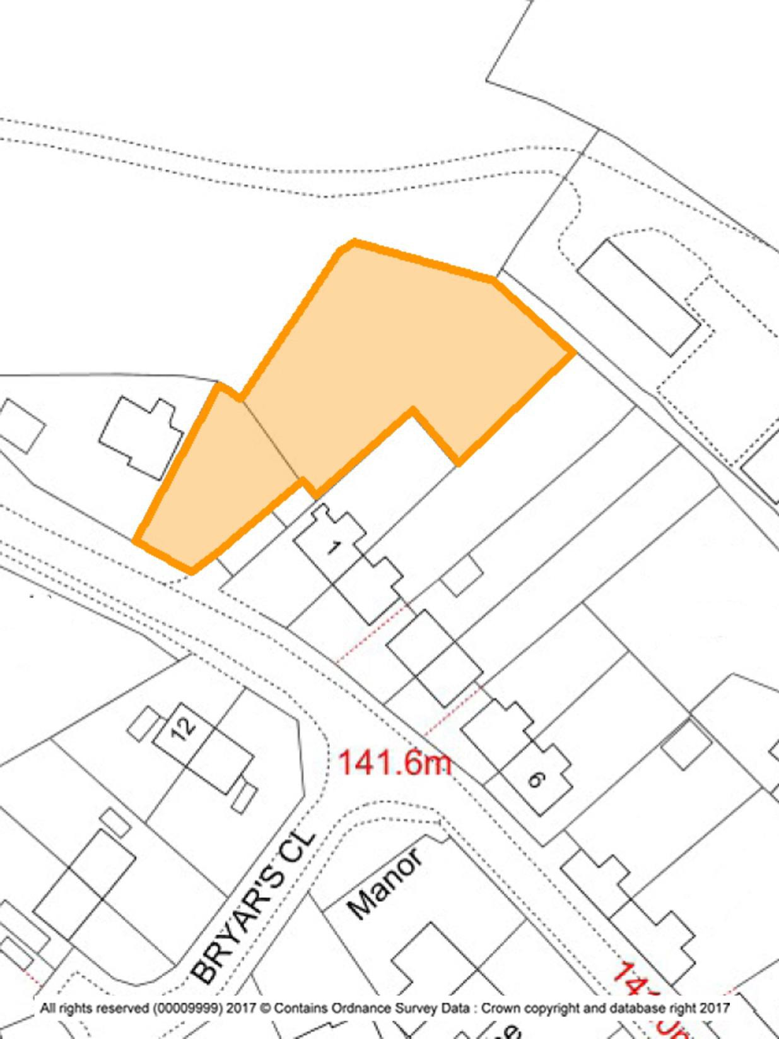

Figure 3: Housing Allocation Site 2 – land off Smeeton Road
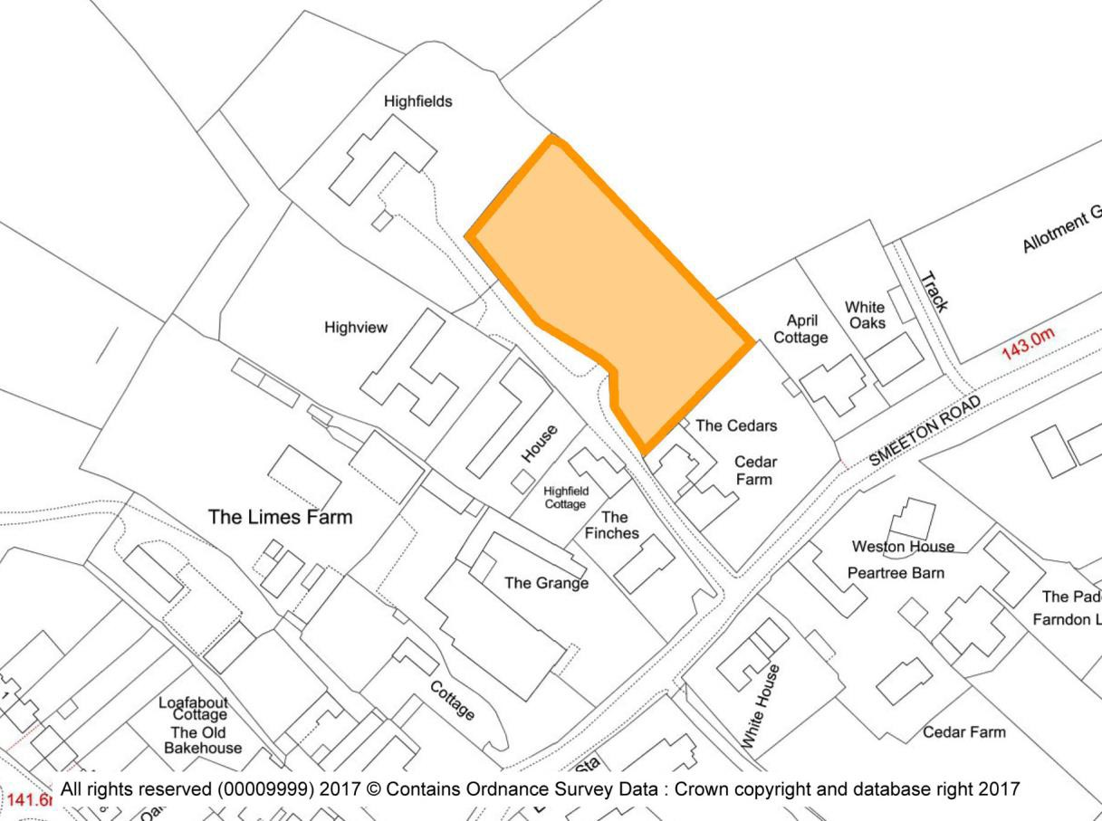

Limits to development
Limits to Development are a commonly used tool in planning documents such as Neighbourhood Plans and District Local Plans. They are used to define the extent of a built- up part of a settlement accommodating sustainable growth locations. They distinguish between areas where in planning terms development would be acceptable “in principle” such as in the main settlement and where it would not be “sustainable”, such as in the open countryside.
As the draft Harborough Local Plan proposes removing Limits to Development in favour of criteria-based policies, the Neighbourhood Plan proposes to designate a revised and updated Limits to Development for the village of Saddington. The proposed Limits to Development is shown below in Figure 4 and was developed following consultation.
Focusing limited development in the village of Saddington will help to support the existing services (the pub and church) whilst helping to protect the countryside from inappropriate development.
Within the defined Limits to Development identified in this Plan, small scale sustainable development will be viewed sympathetically. This development will mainly comprise of infill
– the filling of a restricted gap in an otherwise built up frontage, building on previously- developed land and the conversion of existing buildings. The Parish grew by 25 households between 2001 and 2011 (Census data) and this level of gradual growth is envisaged for the remaining term of this plan. Any development will be required to demonstrate that it meets an identified local need in terms of size and type and is well designed (in keeping with existing buildings) and is appropriately located. If not sensitively undertaken and designed, such development can have an adverse impact on the character of the area. Such new development will generally increase car ownership and there is a need to ensure that it does not worsen traffic and parking issues.
In addition, much of the built-up parts of Saddington have been developed at relatively low densities and there are very limited public green spaces. Some properties are set within relatively large grounds whilst, conversely, others have very limited ground. The spaces between and around buildings contribute significantly to the special character of the village and the wider Parish and maintaining residential amenity. When considering development proposals, it is therefore important to have regard to the impact any development would have on the setting and layout of the surrounding area and on the special views and vistas.
In addition, consultation has highlighted a lack of support for ‘tandem’ and ‘backland development’ defined as the placing of one dwelling behind another within a single plot and the erection of a dwelling or dwellings on parts of large gardens attached to existing dwellings.

Methodology:
The Limits to Development for Saddington, as shown in Figure 4 has been determined using the following criteria:
      - Clearly defined physical features such as walls, fences, hedgerows and roads have been followed;
      - Potential small-scale development areas have been incorporated into the drawing of the Limits to Development to enable housing growth in the future, subject to the requirements specified within the Neighbourhood Plan;
      - Non-residential land which is Countryside, agricultural, paddock, meadow, woodland and/or another green-field use has been excluded;

POLICY H2: LIMITS TO DEVELOPMENT – Within the defined Limits to Development as shown in Figure 4, development proposals for small scale infill development and conversion of existing buildings will be supported where it:
- Reflects the size, character and level of service provision of Saddington;
- Helps meet a clearly identified need in Saddington Parish;
- Retains existing natural boundaries such as trees, hedges, boundaries and streams which either contribute to visual amenity or are important for their ecological value;
- Maintains important views and vistas;
- Retains and where possible, enhances the distinctive qualities of the special and attractive landscape in which Saddington is situated;
- Preserves and where possible, enhances the setting of any heritage asset where the setting of that heritage asset would be affected by the proposal;
- Development proposals in the parish should demonstrate that capacity is currently available within existing wastewater infrastructure or that capacity can be made available in time to serve the development;
- Preserves and where possible, enhances the Saddington Conservation Area.
Figure 4: Limits to Development
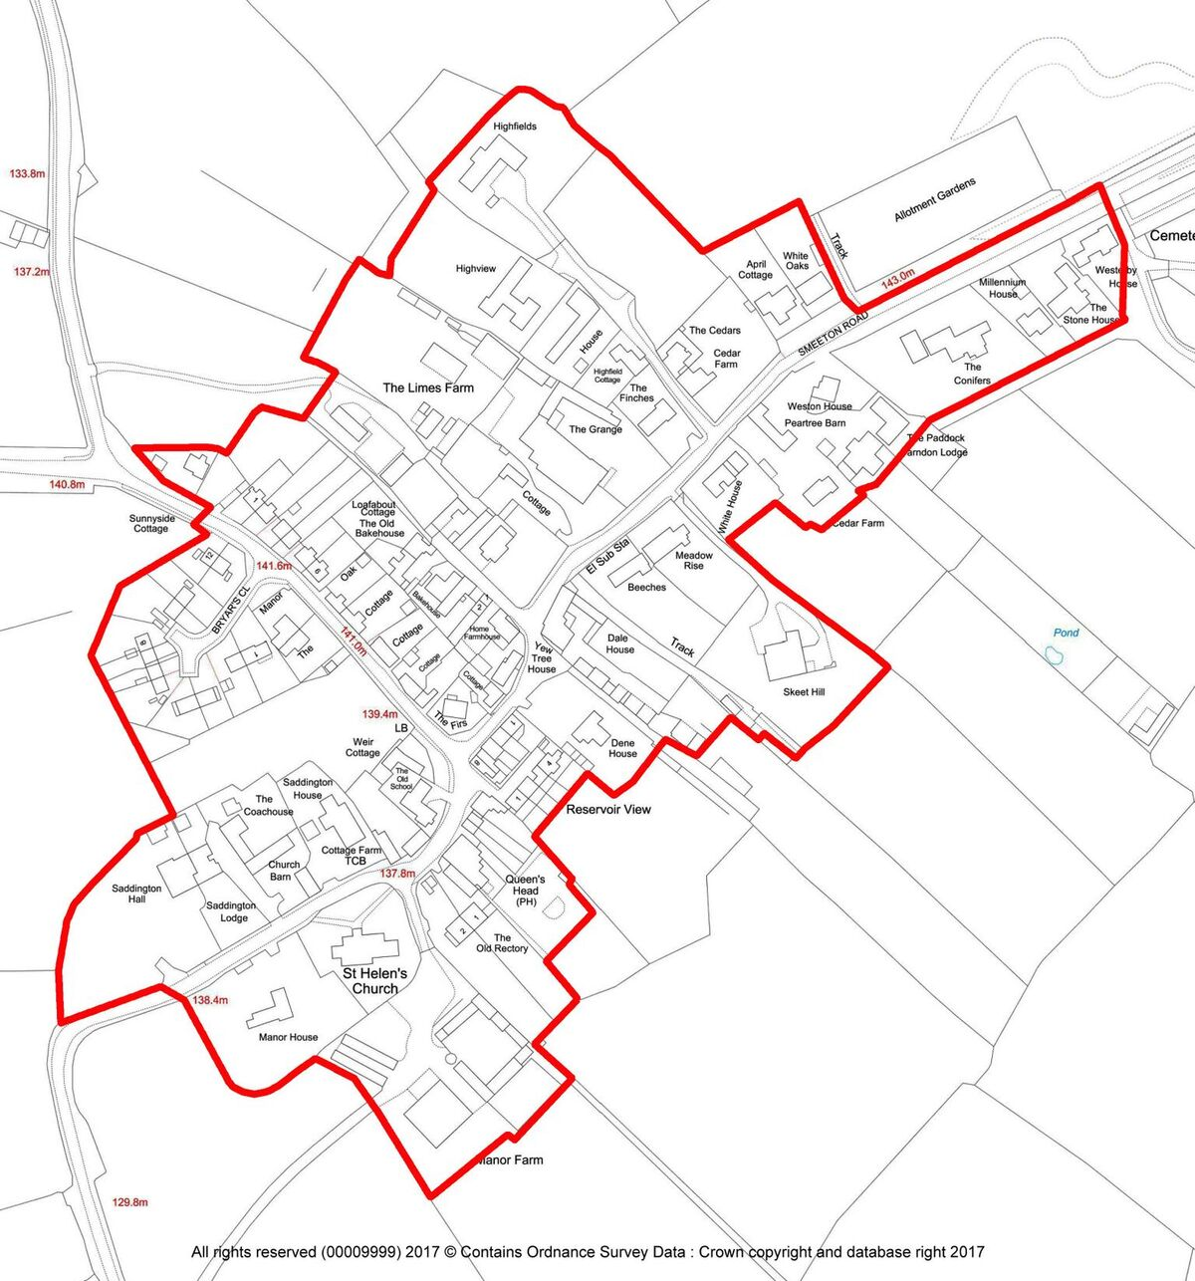

Housing Mix
Evidence from the 2011 Census and other data indicates a current predominance of larger detached housing and fewer smaller homes of three bedrooms or less. Small scale housing developments that provide a mixture of the needed types and tenure of housing will be supported where in line with other Neighbourhood Plan policies.
The proportion of owned properties in the Parish either owned outright or with a mortgage at 76% is marginally below the Harborough district (78.1%) and slightly higher than in the East Midlands (67.3%). The level of social rented accommodation (12%) is higher than Harborough district (8.4%) but lower than the East Midlands area (15.8%). The level of private rented accommodation (10%) is below Harborough district (11.2%) and East Midlands (14.9%).
The Census data provides further evidence of an ageing population, with the number of residents aged 60 and over increasing by 20% (+15) between 2001 and 2011. Population trends indicate that the number of older people will grow significantly in the future and relative growth will be highest in older cohorts. Latest available population projections suggest that Harborough’s 65 plus age group is forecast to grow by around 65% between 2014 and 2034.
Individually designed houses along with bungalows and homes for retired people are the types of dwellings that are most supported by the village.
The following policy will ensure that future housing meets the identified needs of the Parish.;

POLICY H3: HOUSING MIX - New housing development proposals should provide a mixture of housing types specifically to meet identified local needs in Saddington. Development should deliver more than 50% of the units as 3-bed or fewer (which can include accommodation for older people which should be built to the M4(2) Building Regulations 2016 or any future standard updating this).

All proposals will be expected to demonstrate how the proposal will meet the current and future housing needs of the parish as evidenced in the Parish Housing Needs Survey Report 2016 (Appendix 4) and the Leicester and Leicestershire Housing and Employment Development Needs Assessment 2017 or any more recent document updating either of these reports.
    - Brownfield sites
As a positive Neighbourhood Plan the community are keen to support development of previously developed (brownfield) sites, along with the sympathetic conversion of redundant and/or underutilised buildings or land.
This approach is also a core principle of the NPPF (paragraph 17) which is to “encourage the effective use of land by reusing land that has been previously developed (brownfield land), provided that is it not of high environmental value”.
The Adopted Harborough Core Strategy also prioritises the redevelopment of previously developed land in Policy CS1. Development that addresses these issues therefore will be supported.

POLICY H4: BROWNFIELD SITES – Development proposals for the redevelopment or change of use of redundant land or buildings within the Limits to Development will be supported, but development on redundant land of high ecological value will not be supported, unless policies in the development plan that conserve and enhance ecological value are complied with.
    - Design
Saddington village lies in open countryside close to the Grand Union Canal. It sits on a ridgetop overlooking a steep valley in which is a reservoir constructed in the early 19th century to feed the Canal. The Conservation Area includes most of the older core of the village but excludes new development to the north and some modern large agricultural units. It incorporates some new development (including conversions of farm buildings); the former farmyard of Cedar Farm is included because it is intermingled with older buildings and forms a definite entrance to the village from Smeeton Westerby. The village consists of a sinuous Main Street widening in two places to a triangular dog leg area. These are where Weir Road and Bakehouse Lane join Main Street, with the Church and Hall at the south end.
The two dog legs form separate focal points and break up the linearity of the street. The first of these by Bakehouse Lane has a good red brick 19th century building in the corner facing directly down the Main Street and forming a vista stop looking up. Opposite is Yew Tree House, the former Saddington Baptist Chapel (1848) and attached house. The little chapel on the corner looking up Main Street has elliptical rubbed brick window arches and the windows are cast iron with interlacing tracery. Bakehouse Lane has a long mud wall with slate coping.
The second dog leg is by Weir Road and has a green verge on the corner. The side of some 19th century red brick cottages looks down the street. The street here is wider, with granite kerbs, the white colour washed Queens Head Public House and a variety of red brick cottages with slate roofs, many with renewed windows. The visual end to this section is the churchyard wall (stone, river pebbles and granite) with its gate facing up the street. The church with its sandstone and limestone tower, and the churchyard yews close the view. Just to the east is the churchyard a track leads down under trees to an agricultural yard. In the corner between Main Street and this track, behind a garden is the Old Rectory - a fairly plain mid-19th building but with an exceptionally elaborate gothic porch of 1864.
The Conservation Area ends at the south of the village, here is the church and churchyard whose stone wall juts out into the line of Main Street and whose yew trees are prominent. Opposite is Saddington Hall behind high red brick walls. A regency front range was added to an earlier building and faces away from the village towards open countryside and the reservoir. It forms the entry from the south.
An interesting feature of the village is the row of early 19th century red brick farmworkers’ cottages set back from Main Street which are in line with the substantial red brick Dene House set back behind its garden, and together they run set back between the two main street dog legs. Dene House looks towards Main Street to the former Baptist Chapel whereas the Reservoir View Cottages look away from the village and over the valley and reservoir. Good views of valley and reservoir can be seen from the car park, behind the Queens Head Public House and seen through its windows from Main Street.
Saddington is a village of a curving Main Street with many corners. It stops abruptly by the church and Hall. Red brick buildings of varying ages and qualities and red brick boundary walls predominate. The roofing materials were originally Swithland slate and Welsh slate of both of which some remains; but these have in many cases been replaced by concrete tiles.
It is clear that Saddington has a long and interesting history, resulting in a wide array of heritage assets, attractive landscapes and a distinctive local character. The biggest challenge facing the future of the Parish is balancing the desire to protect the character of the village with the opportunity to grow and evolve in a sensitive and proportionate manner in order to sustain the community and its facilities.
The policies in this section seek to reflect the design principles which the community believes will help to achieve this aim.
The overall aim is to retain the character of the village within a unique and distinctive Parish. This can be achieved by the use of the planning system sensitively to respond to the wide range of historic buildings, styles, structures, landscapes and archaeology situated within the Parish. These assets form many of the key characteristics of the Parish, and future developments should seek to enhance this distinctive environment.
In this section therefore, the Neighbourhood Plan sets out the planning policies which seek to identify and maintain these distinctive elements which together provide the special qualities of the landscape setting and built heritage of Saddington Parish.
New development proposals should be designed sensitively to sit within the distinctive settlement patterns of Saddington. Existing settlement patterns have grown incrementally over time. The buildings date from many different periods, providing a richness and variety of styles and materials.
This traditional rural character should be enhanced by new development and schemes should be designed to ensure that new buildings sit comfortably within the existing settlement pattern and are respectful of their surroundings.

POLICY H5: BUILDING DESIGN PRINCIPLES - All new development proposals of one or more houses, replacement dwellings and extensions should have regard for the following building design principles to a degree that is proportionate to the development:
- Care should be taken to ensure that the development does not disrupt the visual amenities of the street scene and impact negatively on any significant wider landscape views.
- New buildings should follow a consistent design approach in the use of materials, fenestration and the roofline to the building. Materials should be chosen to complement the design of the development and add to the quality of character of the surrounding environment and of the Conservation area.
- All new housing should reflect the character and historic context of the existing developments within the Parish, however, contemporary and innovative materials and design will be supported where positive improvement can be robustly demonstrated without detracting from the historic context.
- Development should enhance biodiversity and relate well to the topography of the area, with existing trees, boundaries and hedges preserved whenever possible.
- Development should incorporate sustainable design and construction techniques to meet high standards for energy and water efficiency, including the use of renewable and low carbon energy technology, as appropriate.
- Roof and wall construction following technical best-practice recommendations for integral bird nest boxes and bat breeding and roosting sites.
- Hedges (or fences with ground level gaps) for property boundaries that maintain connectivity of habitat for hedgehogs.
- Security lighting shall be operated by intruder switching, and not on constantly. Site and sports facility lighting to be switched off during ‘curfew’ hours between March and October, following best practice guidelines in Bats and Lighting Leicestershire & Rutland Environmental Records Centre (LRERC) 2014. Maximum light spillage onto bat foraging corridors should be 1 lux.
    - Light Quality
Saddington village currently has a total of 3 street lights. These are the yellow sodium type of light, and are illuminated from dusk to dawn via a photoelectric switch.
The Parish Meeting is concerned to limit the increase in street lights within Saddington. This is driven by the environmental benefits of limiting street and security lighting; the amenity benefits to households of limiting intrusive security lighting on adjacent properties and the economic benefits of reducing the cost of lighting and light pollution.
The work undertaken by the Parish Meeting is supported by the NPPF. Paragraph 125 states that planning policies “should limit the impact of light pollution from artificial light on local amenity, intrinsically dark landscapes and nature conservation”.
NPPF paragraphs 95 & 97 support low carbon emission and a reduction in energy consumption. Part of the vision within the Draft Local Plan seeks to minimise light pollution and to contribute to a low-carbon environment.
Accordingly, this Neighbourhood Plan will require that any developments within the Parish should only feature on-street and external wall mounted lighting that is appropriate and sympathetic to the context, and consistent with the density and output of the lighting used in the surrounding area. Consideration should be made to maximise energy efficiency and minimise light pollution, all light being directed ground-ward.

POLICY H6: USE OF STREET LIGHTING - Development must limit the impact of light pollution, including from security lights and from artificial externally visible light sources.
The use of on-street lighting will be appropriate and sympathetic to the context and consistent with the density and output of the lighting used in the surrounding area. Street and curtilage lighting in new development should be at low level only and controlled so that wildlife (specifically bats) is not harmed. Any new or replacement street lights or curtilage lights are strongly encouraged to use LED (or better, for low energy and lifetime) sources and be adequately shaded to prevent upwards light-spill.

  - Natural and Historical Environment
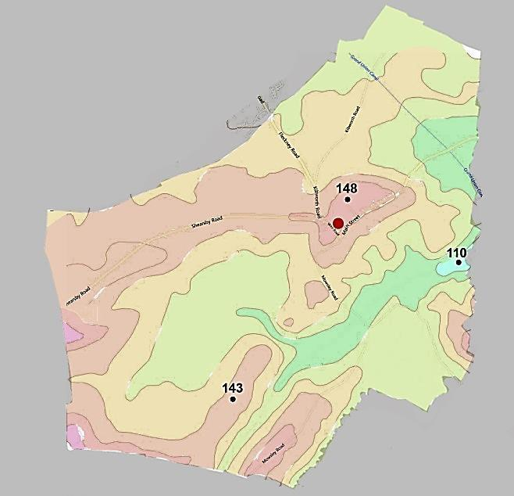
    - Introduction
Landscape, geology and setting
Saddington is a hilltop village about 14 kms (9 miles) southeast of Leicester, on the northern side of an area of high land separating the valleys of the Welland (to the southeast) and Soar (to the north). This ridge is subdivided by a number of small, steep-sided valleys, giving the Neighbourhood Area an attractive, rolling appearance and both extensive and intimate views. Elevations range widely, from 105m to 145m (360 to 475 ft) between the lowest stretch of Langton Brook and the highest point in the village.
Contours and heights (in metres) in Saddington
(Adapted from Google topographic mapping)

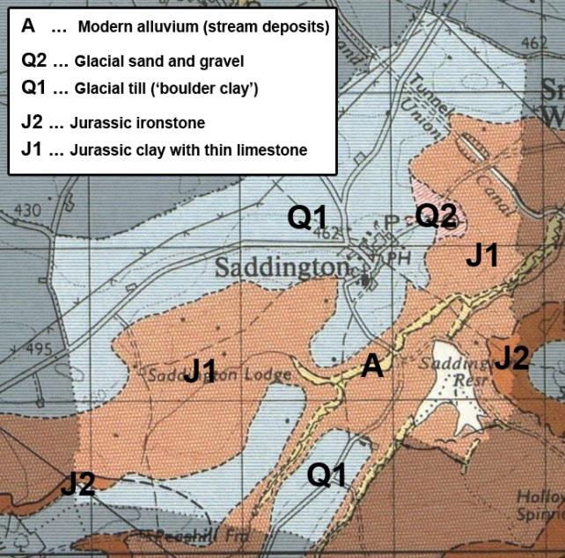
The whole parish is underlain by Jurassic (about 200 million years old) clay, limestone and ironstone; fossilised remains of marine animals from this time, including ammonites, can still be found where the clay is exposed. Except in modern stream valleys this ‘solid’ bedrock is largely covered by ‘superficial’ glacial deposits – ‘boulder clay’ (till), sand and gravel (Quaternary, about 300,000 years old). Because of the preponderance of clay, soils are generally heavy, and farming remains fairly mixed with both arable and grazing land, relatively small fields, spinneys and mature, species- rich hedgerows.

Geological map of Saddington parish
(Adapted from BGS mapping)
Saddington village is a small, nucleated settlement whose character is founded on its historic and modern farming economy as well as its setting, which (although close to the city of Leicester) remains intensely rural. It is part of what local people call the ‘golden triangle’ – with Gumley, Mowsley and Laughton – of peaceful, out-of-the-way villages.
A distinctive landscape component of the parish is the group of features connected with the old Union Canal (the ‘Leicester Line’, Leicester to Market Harborough). The canal’s summit is at Saddington tunnel, while a system of feeder channels supplies water to the canal from Saddington reservoir. The whole complex, constructed 1793 – 1797, is of high significance both historically and for its biodiversity.
Historic environment
From finds of stone artefacts in the area we know that humans were here in both the Palaeolithic and Neolithic periods (between c.12,000 and 4000 years ago), but there were no permanent settlements. Similarly, ‘British’ (Celtic, Iron Age) finds and sites in adjoining parishes and a Roman bronze cloak ring in Saddington point to settlements of this age here.
The village itself originated as the hub of a ‘Dark Ages’ territory, perhaps in the 7th century AD. The place name is pure Old English and is thus a record of continuous habitation of the village, begun by a small group of Anglo-Saxon people whose forebears had arrived here from Europe via East Anglia, for some 1,400 years:

‘Farm/settlement connected with the people of Sada/Saehaeth', or perhaps
'farm/settlement at the pit place'.
- Sada - Personal name. (Old English), OR Sēað (Old English) A pit, a hole
- - ing (Old English) Place-name forming suffix (the people of… OR the place of...)
- - tūn (Old English) An enclosure; a farmstead; a village; an estate

Key to English Place Names: http://kepn.nottingham.ac.uk/map/county/Leicestershire
Saddington is recorded in the Domesday Book (1086), while earthworks just outside the modern village show its greatest extent during the medieval period, probably in the 13th century. Together with ridge and furrow (dating from the same time to the early 18th century), these medieval earthworks are an important, tangible link with Saddington’s history. So is the modern village’s layout, because this still more or less follows the pattern of medieval streets and dwellings, with many of today’s open spaces and gardens on what would have been cottagers’ crofts or yeoman farmers’ closes. Although most of the present buildings date from the 19th and 20th centuries, several Listed Buildings have medieval origins, while other important structures include the premises of the village’s predominantly agricultural tradespeople and (later) framework knitters, and 20th century (rural workers’) Council Houses.
Gravel workings (as, possibly, recorded in the place name) have been a feature of Saddington historically; the sites of several survive, some with modern uses. Also historically important are the extensive features associated with the canal (1793 to present), and the distinctive pattern of fields, hedges and woodland: the survival of small permanent grass fields and species-rich hedgerows is the result of the extended process of Enclosure (late medieval to 1770) combined with the undulating topography of the parish.

Natural environment
The biodiversity of the Neighbourhood Area is generally good by comparison with much of
southeast Leicestershire, thanks largely to its topography and landscape history: the distribution of arable and pasture land (a relatively high proportion of permanent grass fields), varying aspect and drainage, several small natural and artificial watercourses, a substantial ornamental lake, surviving old hedgerows, coppices and ornamental woodlands, all provide a variety of habitats for animals and plants. Large and mature trees (individual and groups) are a valued feature of the village landscape. There are also the two highly valued ecological features of Saddington Reservoir and the canal, whose biodiversity enrichment effect extends beyond their boundaries to augment that of the wider parish.

Existing environmental designations
Saddington is located in the southern part of National Character Area 94 Leicestershire Vales (a Natural England landscape area, defined for Planning purposes); this is characterised by its “villages, buildings and features of historic interest … views toward higher ground … rural feel
… mixture of pastoral and arable farming [and] surviving example of ridge and furrow”.
There are nine Listed Buildings of national importance, seven further extant sites and features of historical significance (Leicester & Rutland Historic Environment Records), two Sites of Special Scientific Interest (SSSIs), and nine mapped areas of Priority Habitat (as defined by Natural England).

Environmentally significant characteristics of the Neighbourhood Area
- Undulating landscape, steep slopes, 40m+ between highest and lowest.
- Outstanding views, both distant and intimate.
- Hilltop site, nucleated village.
- Important mature specimen trees (individual and groups) of arboricultural interest.
- ‘Greenways’ leading into and within the built-up area; community-managed, important for views and for defining the village layout.
- Variety of intermixed buildings of vernacular architectural styles from 17th to 21st century.
- High level of outdoor activity opportunities, with positive impact on landscape, biodiversity, local economy and health and wellbeing (sailing, riding, cycling, walking, bat and birdwatching, hunting, fishing, etc.).

Environmental inventory
An environmental inventory (Appendix 5) of Saddington was carried out between June and September 2017. The work comprised two elements:
- Review of all existing designations and available information, and
- Fieldwork to identify site and features of natural and historical environment significance in the context of the Neighbourhood Area.
The review compiled information from many sources, including Department for Environment Food & Rural Affairs (DEFRA), Natural England, Historic England, Leicestershire & Rutland Historic Environment Records Leicestershire & Rutland Environmental Record Centre records (biodiversity and geology), Environment Agency, British Geological Survey, old maps (Ordnance Survey, manuscript), British History Online, local history and archaeology publications, local knowledge.
Fieldwork reviewed all open and currently undeveloped land in the Neighbourhood Area, and significant species, habitats, landscape characteristics, earthworks and other extant features were checked.
These data, along with all relevant site-specific information from the existing information review, were mapped and tabulated, and each site was scored and evaluated using the nine criteria for Local Green Space selection (LGS) in the National Planning Policy Framework 2012:
Figure 5. Environmental inventory scoring system used in the Plan

Criterion (NPPF 2012) | Score range |  |  | Notes
ACCESSIBILITY | 0 | 1-3 | 4 | e.g. private, no access (0) – visible from public place –  accessed via Public Rights of Way – fully open to the public (4)
PROXIMITY / LOCAL | 0 | 1-3 | 4 | Distant (0) --- fairly near to --- adjoins (3) or is within  (4) settlement
BOUNDED | 0 | 1-3 | 4 | Individual parcel of land (not an undefined or large area)
SPECIAL TO COMMUNITY | 0 | 1-3 | 4 | Opinion of local people e.g. via questionnaire or at consultation events
RECREATIONAL / EDUCATIONAL USE | 0 | 1-3 | 4 | Actual or potential, informal sports, dog-walking, Forest School use, informal or official open space, etc.
BEAUTY (including views) | 0 | 1 | 2 | Subjective, relative (give justification); use consultation map results
TRANQUILLITY | 0 | 1 | 2 | Subjective, relative (give justification)
HISTORICAL SIGNIFICANCE | 0 | 1-3 | 4 | Extant, visible evidence. Number of periods/features/records etc. / Relevant existing designations (Historic Environment Records)
WILDLIFE SIGNIFICANCE, GEOLOGY | 0 | 1-3 | 4 | Richness of species and habitats (Priority Biodiversity Action Plan spp./Priority habitats) / relevant existing designations (Habitat Survey, Local Wildlife Sites / site of geological/industrial history significance
[Maximum possible score] |  |  | 32

Environmental protections
In the NPPF, the natural and historical environment is acknowledged to be an essential component of sustainable development; as such this Plan gives it equal weight against social and economic growth, including new development.

This section identifies land and features of environmental significance in Saddington. It includes policies to protect the best from loss or damage by allocating them to categories, as follows, based on their type, importance, function (as community assets, for example) and intrinsic value.

Note on the environmental evidence in this Plan
Assessment of the ecological and historical significance of sites in the Neighbourhood Area, and of the occurrence and distribution of significant species and habitats, has been carried out by residents in accordance with the requirements of the National Planning Policy Framework (2012), Planning Practice Guidance and Neighbourhood Plan Regulations.
Paragraph 77 of the NPPF states: “Whether to designate land [as LGS] is a matter for local discretion…”. Planning Practice Guidance requires that ‘proportionate, robust evidence should support the choices made and the approach taken’.
Environmental assessments are required to be undertaken with a greater level of detail and resources than is considered to be appropriate for the content in the Neighbourhood Plan.
This Plan applies the NPPF criteria for selecting Local Green Space to all parcels of land of environmental significance. Only the highest scoring sites are considered for LGS designation, but the information gathered on the other sites that have been assessed has identified locally important (and valued) environmental features to be taken into account when new development is under consideration by the Local Planning Authority. The rationale for this approach is that if statutory protection can be afforded to Local Green Space using ‘local discretion’, the less restrictive policies relating to other sites of local environmental significance can also be supported by evidence collected and evaluated locally.
Evidence in support of the NPPF environmental criteria historical significance and richness of wildlife has therefore been collected and evaluated by the volunteer members of the Environment Theme Group of the Neighbourhood Forum. The work of these local residents has been augmented by:
        - Publicly available information resources about all site-specific, relevant, environmental features of the parish, including DEFRA, Natural England, Historic England, the Environment Agency, British Geological Survey, and others.
        - Advice, information and guidance from YourLocale’s (the Plan’s Neighbourhood
Planning Consultants) environmental specialist;
        - Leicestershire & Rutland Environmental Records Centre data and maps (historic and natural environment, including Local Wildlife Sites, Leicestershire Historic
        - Environment monuments (polygons) and non-Listed buildings (locations);
        - Informal advice from subject matter specialists who live in the parish (species lists, oral history, etc.).
The process as described ensures thorough environmental assessments are undertaken utilising local knowledge and informed by specialist input to ensure that development takes into account important environmental features and levels of protection in line with the degree of local importance of the site in question. Higher resolution maps are available in the supporting information.
    - Area of Separation
New development in the area between the Limits to Development and the Parish boundary alongside the built-up area of Fleckney would encroach on open countryside and encourage direct coalescence of the two settlements.
The Area of Separation Review commissioned by Harborough District Council in 2017 recognises that the function of an area of separation is to ensure that development does not harmfully reduce the separation between settlements where there is a potential risk of merging. The 2017 study reinforces the importance of ‘prevention of coalescence’ and the sense of separation between settlements. The review identifies two large scale and strategic areas for inclusion within the Proposed Submission Local Plan (between Great Bowden and Harborough and Lutterworth/Bitteswell and Magna Park). The review acknowledges that further areas of separation will come forward in Neighbourhood Plans.
The Area of Separation identified within the Neighbourhood Plan has been recognised to help retain the physical separation between the built-up area of Saddington and the adjoining village of Fleckney in order to maintain the identity and distinctiveness of both settlements, as well as their landscape setting, built environment and the views across open countryside. By so doing it will help to preserve the character of Saddington and to prevent harmful encroachment into the countryside. The Area of Separation is host to important ridge and furrow earthworks which are defined as non-designated heritage assets in the Saddington Parish Neighbourhood Plan. The Area of Separation provides additional protection to prevent loss of these nationally important assets.
The boundary extends up to the border with Fleckney Parish because development linked to Fleckney would create a satellite settlement of Saddington that is disconnected from the village itself whilst also being distant from the facilities in Fleckney itself. The Area of separation seeks to recognise the difference in scale and character between Fleckney (large housing developments and industrial settings) and Saddington (deeply rural, small settlement, surrounded by open countryside in a sensitive HDC Landscape Character Area).
This is undertaken in awareness of the considerable large-scale developer interest in developing the land between these two communities.
The Area of Separation represents that area which is necessary to be maintained as open land so as not to reduce the existing degree of separation between the two settlements. This policy is given added weight by the identification of two housing sites within the Parish which offer a positive contribution to meeting both a local need and the District’s wider housing target. Saddington is not required through the Proposed Submission Local Plan to identify any specific housing sites but has done so to contribute positively to meet housing need and to afford added protection to other areas of open space within the Parish that are important to the local community.
In doing so, the Neighbourhood plan follows the principle established within the Area of Separation Review in drawing the area of separation between Harborough and Great Bowden, namely to designate the whole area between the two settlements in recognition of the harm that would be caused by the encroachment by development in this area.
Figure 6: Area of Separation
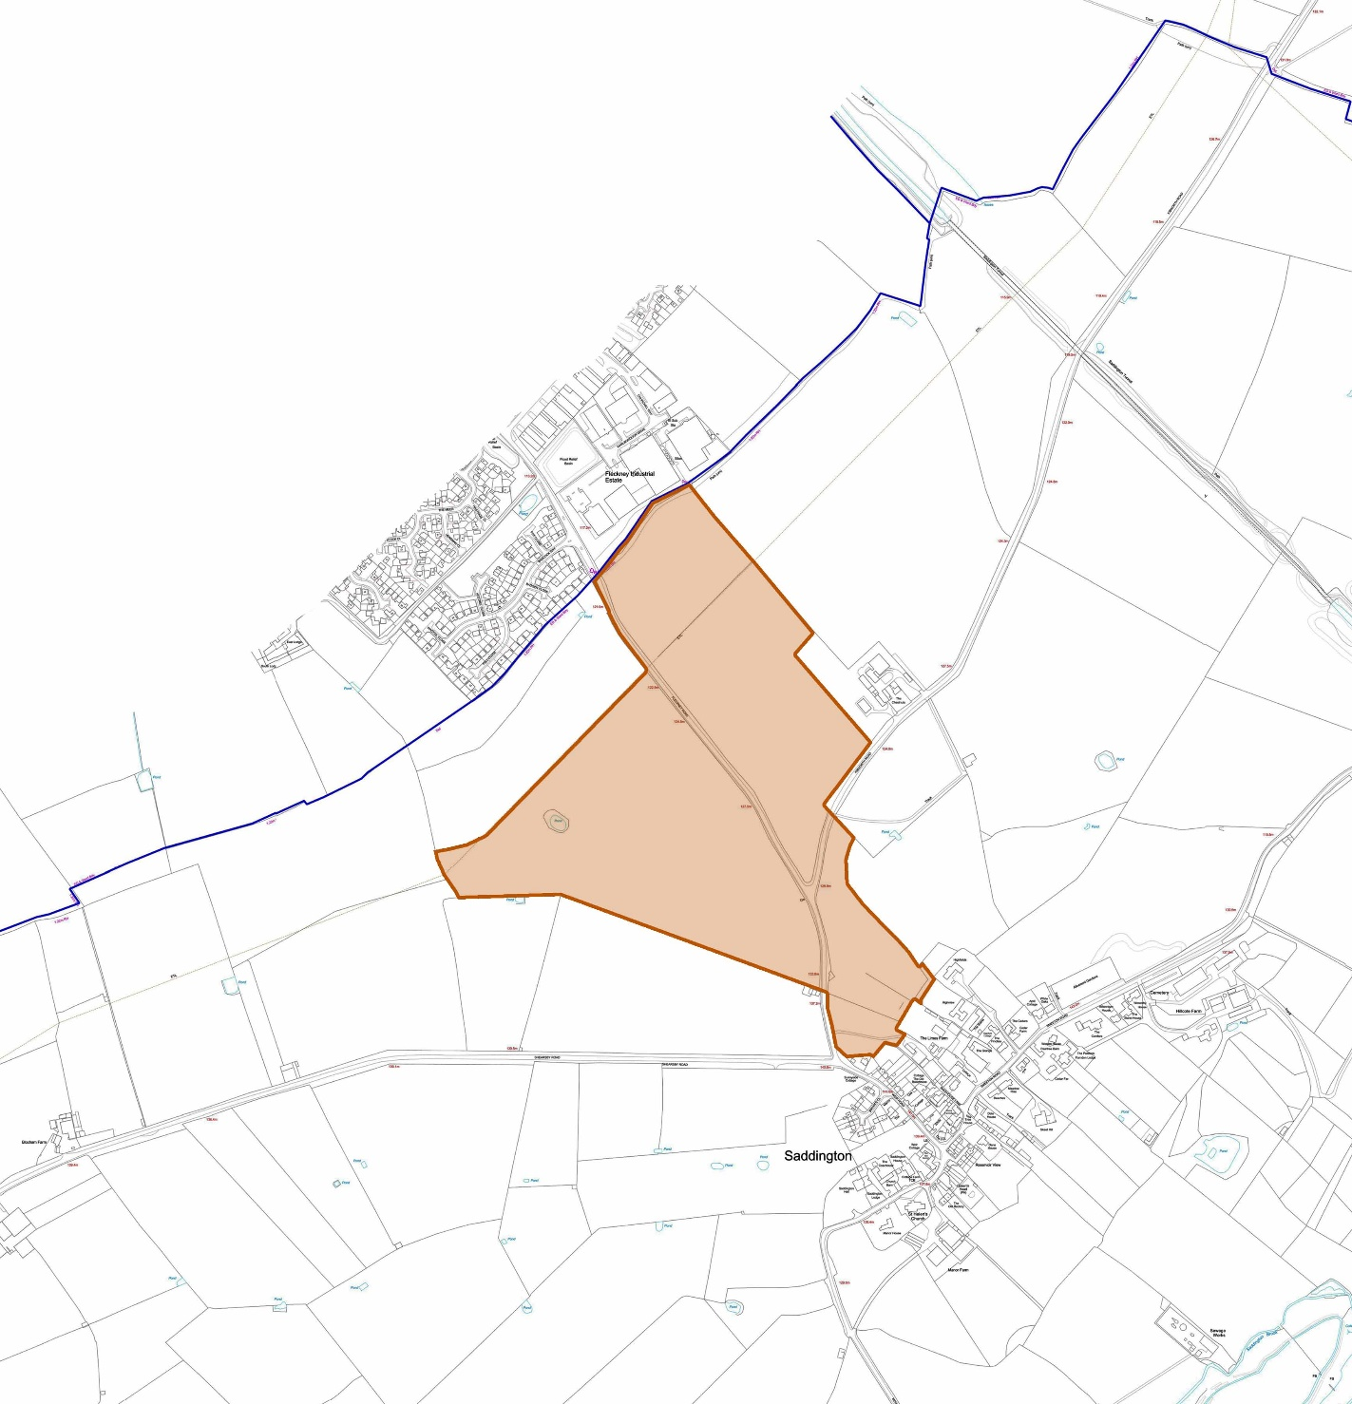

POLICY ENV 1: AREA OF SEPARATION – To retain the physical and visual separation between Saddington and Fleckney, an area of open land will be designated as an Area of Separation as shown above (Figure 6). Development proposals in the identified gap between villages should be located and designed to maintain, and wherever possible, enhance the separation of the villages.

    - Local Green Spaces
Of the approximately 175 inventoried parcels of open land in the parish (refer to appendix 5) some 26 were identified as having notable environmental (natural, historical and/or cultural) features. These sites were scored, using the nine criteria for Local Green Space designation noted in the National Planning Policy Framework 2012 (see figure 5 for the criteria and scoring system adopted for this Plan).
Five sites score 75% (24/32) or more of the maximum possible and meet the essential requirements for designation as Local Green Space as outlined in the National Planning Policy Framework (NPPF paragraph 77). Two are already protected by national designations (as SSSI and Listed Building, respectively). Designation of the remaining three as Local Green Space will ensure that these most important places in Saddington’s natural and human environment are also statutorily protected, other than in exceptional circumstances.
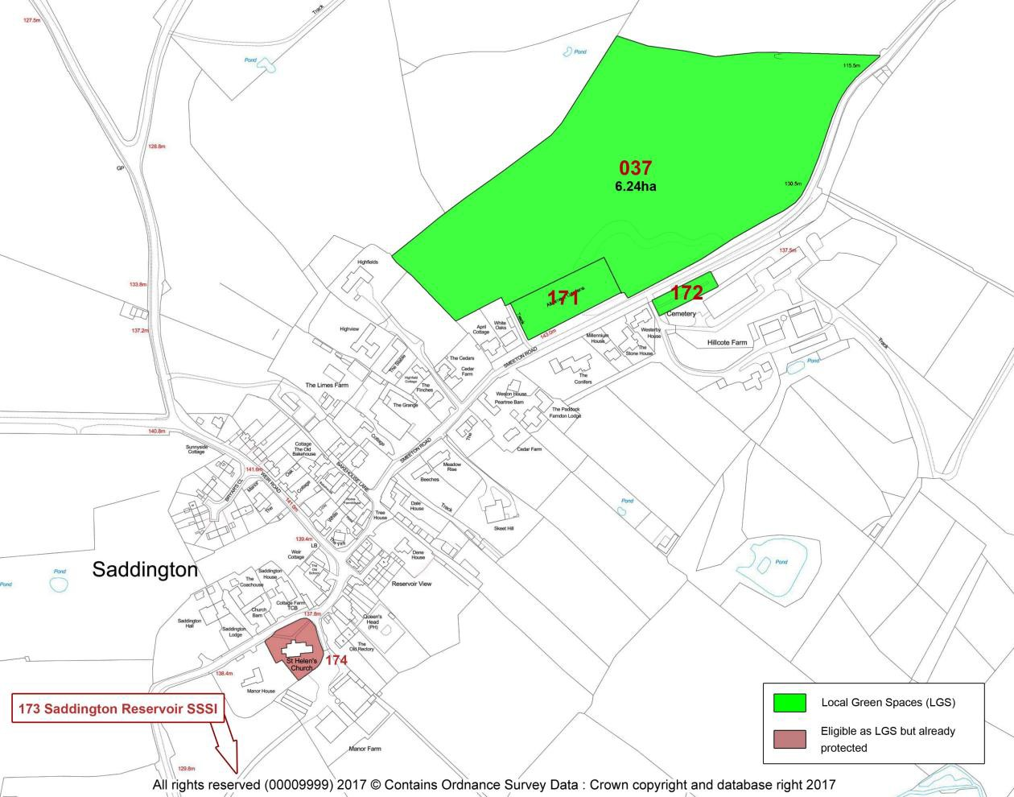
Figure 7: Local Green Spaces

POLICY ENV 2: LOCAL GREEN SPACES – Development proposals that would result in the loss of, or have an adverse effect on, the following Designated Local Green Spaces (refer to Figure 7 with map and details above), will not be permitted other than in very special circumstances:
Bullbeds (Inventory reference 037)
Allotment gardens (Inventory reference 171)
Saddington Cemetery (Inventory reference 172)

Sites of environmental significance
Figure 8: Sites of natural and/or historical environment significance
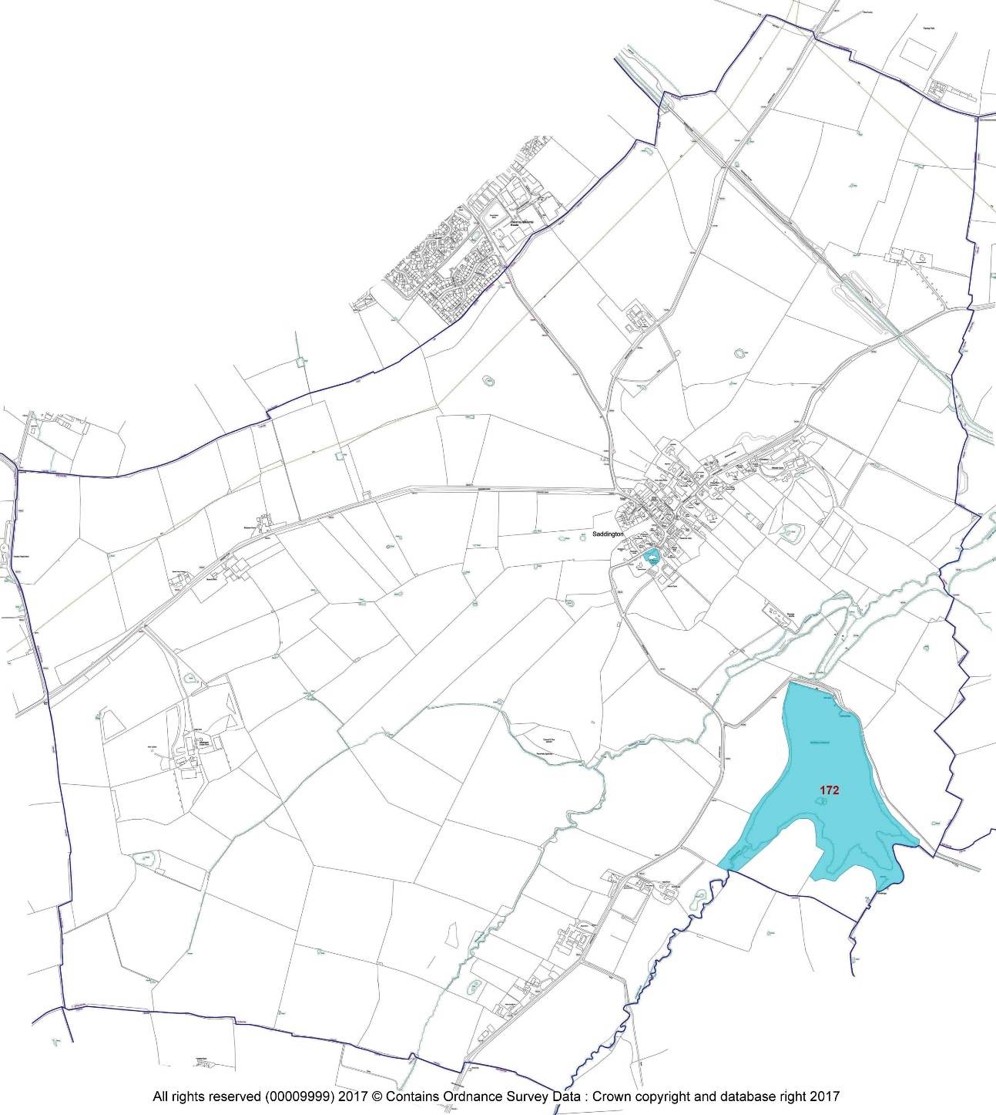
A second group of inventory sites scores highly for ‘history’ and ‘wildlife’ (scoring at least 4 / 8 under these two criteria) but, because their community value scores are not high enough they are not eligible for Local Green Space designation. The features for which the identified sites have been selected and notified are listed in the environmental inventory (Appendix 5).
The historical environment sites comprise a) sites with extant and visible archaeological or historical features recorded in the Leicestershire & Rutland Historic Environment Records database; b) good-quality ridge and furrow fields (for details see Policy ENV 7); and c) other sites of historical and social significance identified in local records and during the inventory process.
The natural environment sites comprise a) those where priority habitats occur (Natural England mapping) or where biodiversity action plan (BAP) species have been recorded as breeding or as regular visitors; and b) sites identified during the inventory process as being of high biodiversity significance in the context of the Neighbourhood Area.

POLICY ENV 3: PROTECTION OF SITES AND FEATURES OF ENVIRONMENTAL SIGNIFICANCE –
The following sites shown on figure 8 have been identified as being of local significance for biodiversity (species and habitats) and / or history. They are important in their own right and are locally valued. Development proposals that affect them will be expected to protect or enhance the identified features.
- Saddington Reservoir
- St Helen’s Churchyard
    - Important Open Spaces
A small group of sites scored highly in the inventory (scoring at least 75% of the possible total under the relevant criteria) for their outstanding community value. Some are existing Open Space, Sport & Recreation (OSSR) sites (including those in Harborough District Council (HDC) Consultation documents for Local Green Space (2015), Open Spaces Strategy (2016-2021) and Provision for Open Space, Sport and Recreation (2015-2016) carried out in preparation for the HDC Local Plan (due to be adopted in 2018). Others have been identified in fieldwork and community consultations.
These sites comprise:
Parks and garden / amenity greenspace
Proposed new ‘village green’, Weir Road
Wide roadside verges These are managed by the community in recognition of their high historical and landscape value (tree-lined vistas through the village framing important buildings, with mown grass, spring bulbs and other ornamental plantings)
South and east verges, junction of Weir Road, Fleckney Road and Shearsby Road West corner verge, junction Weir Road and Mowsley Road
Both sides, Mowsley Road at exit from village
South side, Smeeton Road from Yew Tree House to The White House Both sides, Smeeton Road from Cedar Farm to exit from village
Churchyards and cemeteries
Churchyard of St Helen’s Church (174)
Their value as open space within and close to the built-up areas and/or their current, or potential, value, as community resources are recognised in a Community Action (see section 8).

POLICY ENV 4: IMPORTANT OPEN SPACES – Development proposals that result in the loss of, or have a significant adverse effect on, the following areas of public open space (Figure 9) will not be supported, unless the public open space is replaced by an equivalent or better provision in an equally suitable location or it can be demonstrated that the public open space is no longer required by the community.
Figure 9: Important Open Spaces
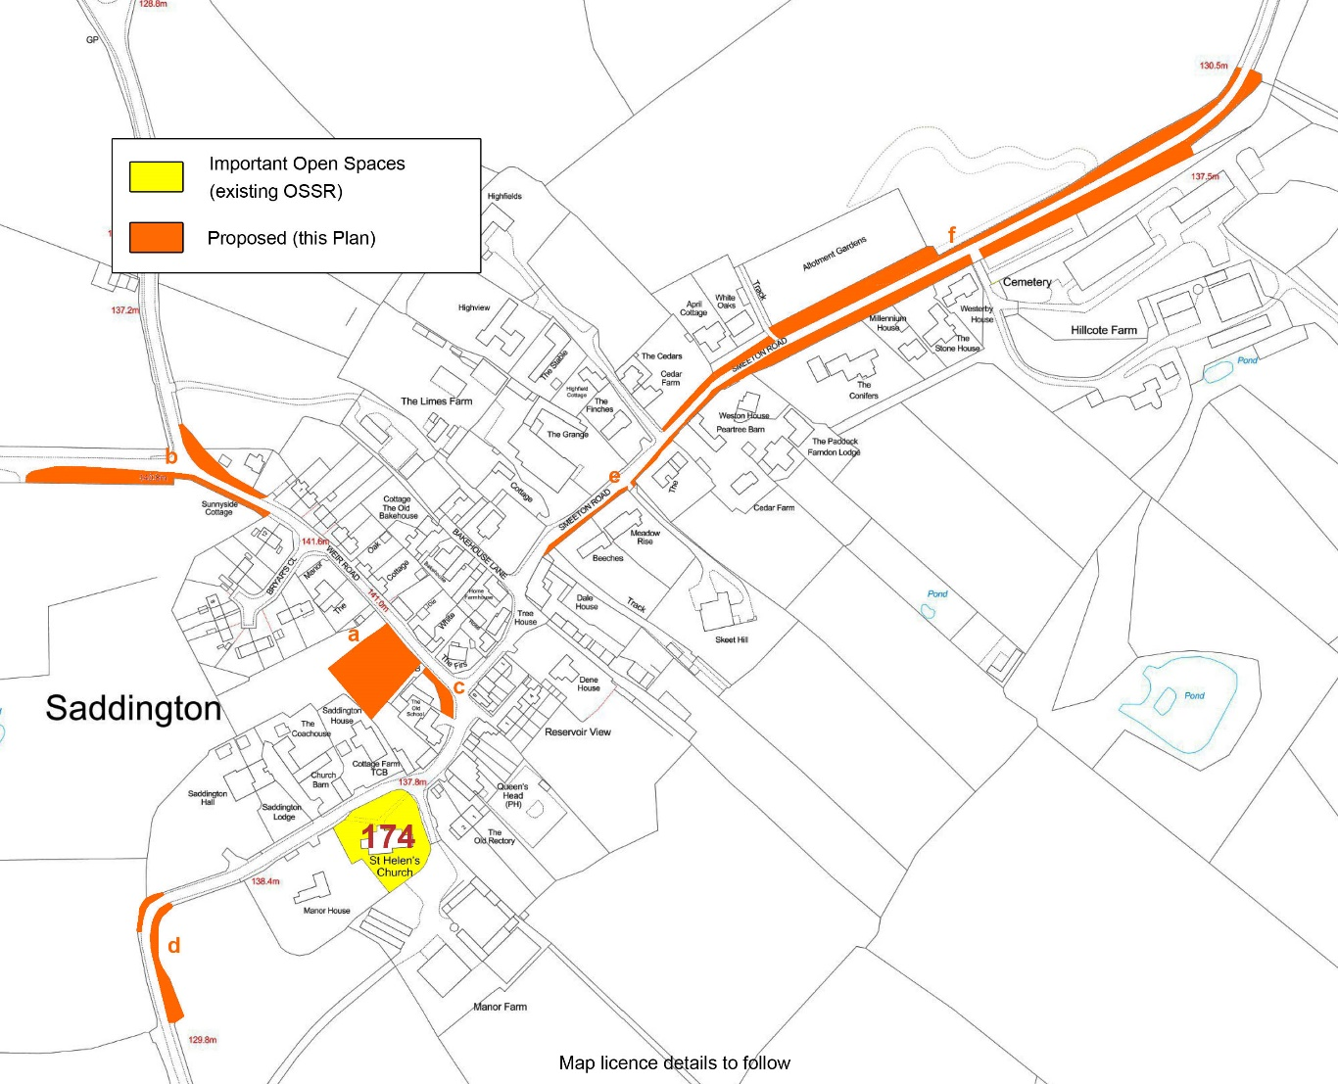

Biodiversity, trees, hedges and wildlife corridors
Wildlife, both habitats and species, is of great importance for many reasons; it is valuable in its own right, and people take great pleasure from thriving natural surroundings. Well-functioning ecosystems are vital for a healthy environment and contribute to physical and mental health and wellbeing.
Biodiversity (species and habitats) protection and enhancement is supported by the National Planning Policy Framework 2012, which is itself compliant with the UK Conservation of Species and Habitats Regulations, 2010, Amended 2012, and the European Habitats Directive 1992 (Council Directive 92/43/EEC on the Conservation of natural habitats and of wild fauna and flora).
Trees and hedges are an important component of the Neighbourhood Area; in particular, community consultation shows that a number of individual and groups of old and mature trees of arboricultural interest and landscape value are a valued feature of the village.
This policy articulates a local wish for Saddington to play its part in achieving the important objectives of national and international legislation at the level of individual sites and features in a single parish – the level at which all effective biodiversity conservation must actually take place. Recognition of these wildlife corridors in the Planning system will be part of this, as will be the exhortation that developers comply with species and habitats protection regulations by delivering on Planning Conditions in full.

POLICY ENV 5: BIODIVERSITY AND WILDLIFE CORRIDORS - Development proposals will be expected to safeguard locally significant habitats and species and, where possible, to create new habitats for wildlife.
Trees and hedgerows of good arboricultural, biodiversity and amenity value should be protected from loss or damage as a result of development. Wherever possible, they should be integrated into the design of development proposals. Development proposals should be accompanied by a tree survey of at least (currently) BS5837 standard, or the standard in force at the time, that establishes the health and longevity of any affected trees.
Development proposals should not damage or adversely affect the wildlife corridors identified on the map below. Development should not create barriers to the permeability of the landscape for wildlife in general, or fragment populations of species of conservation concern.
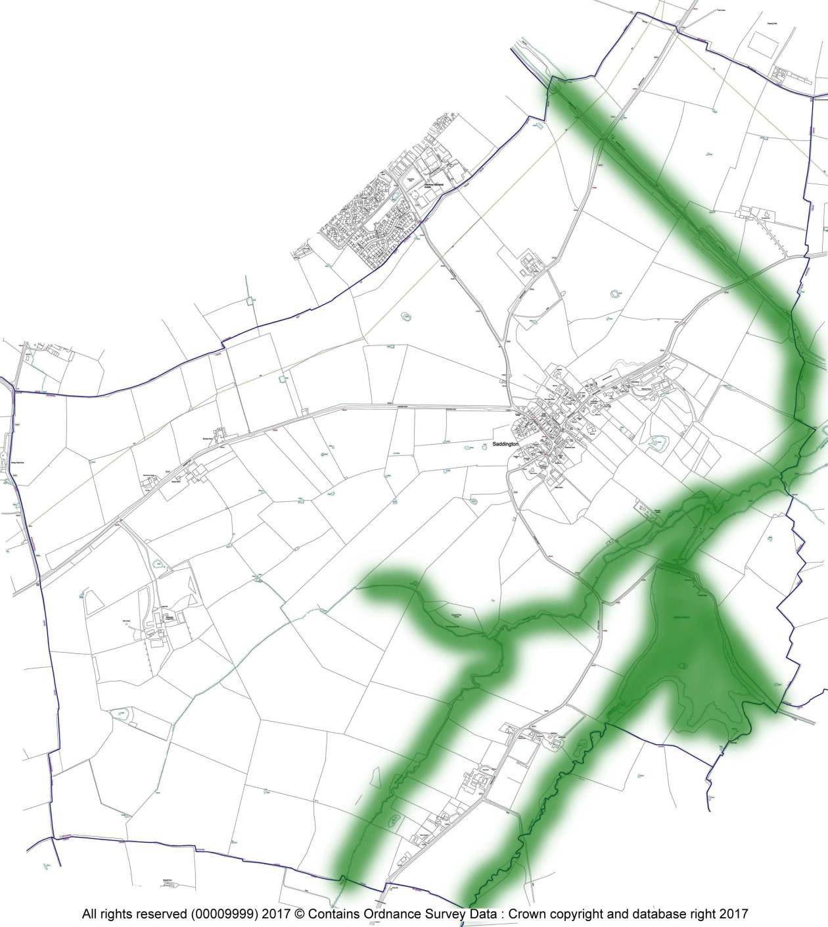
Figure 10: Wildlife corridors

Buildings and structures of local significance

LISTED BUILDINGS

Nine buildings and structures in the Neighbourhood Area have statutory protection through Listing at Grade II* or II. and these contribute to the overall high-quality architecture of the village core. The Neighbourhood Plan lists them for reference, and to note that new development will be required to take into account their settings on a case by case basis. They are already legally protected through their Listed Building Status and are shown here below:

- Baptist Chapel
- Cedar House and Garden Wall
- Church of St Helen
- Harlain (Loafabout) Cottage
- Ivydene
- Limes Farmhouse and Garden Wall
- Saddington Hall and Garden Wall
- Sunnydale Farmhouse (Dale House)
- Yew Tree House
Their designation as a Listed Building gives them special legal protection. It is important, however, that the Neighbourhood Plan highlights them, especially to ensure that all parties are aware of their local importance and merit, and the need to protect and enhance these structures. Development proposals that affect a Listed Building or any other nationally designated heritage asset will be considered in accordance with national and district-wide planning policies.

LOCAL HERITAGE LIST
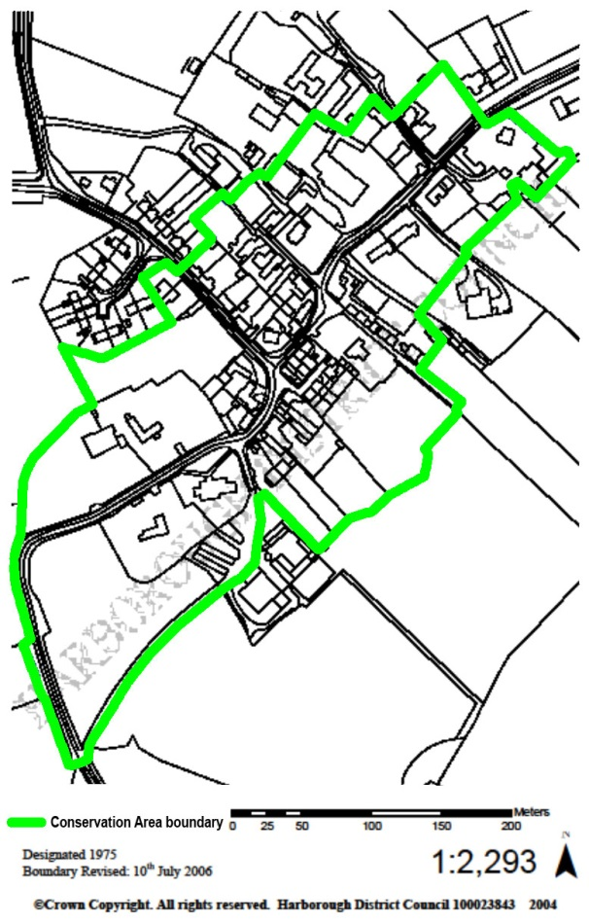
In addition to these nationally recognised Listed Buildings and the special protection this brings, there are other buildings and structures that have been identified as being locally important to the architectural and historic heritage of Saddington and need to be preserved and enhanced. These buildings will be Locally Listed in this Plan
The Neighbourhood Plan recognises the importance of Saddington Conservation Area and the need to protect its character. It supports proposals that preserve and enhance the unique character of this area.
The buildings described below are considered to be of local significance for architectural, historical or social reasons (details in Appendix 9). They are included here as non-designated heritage assets and their locations are shown in Figure 12.
Figure 11: Saddington Conservation Area (based on HDC map)

Figure 12: Local Heritage List for Saddington: buildings and structures of local significance
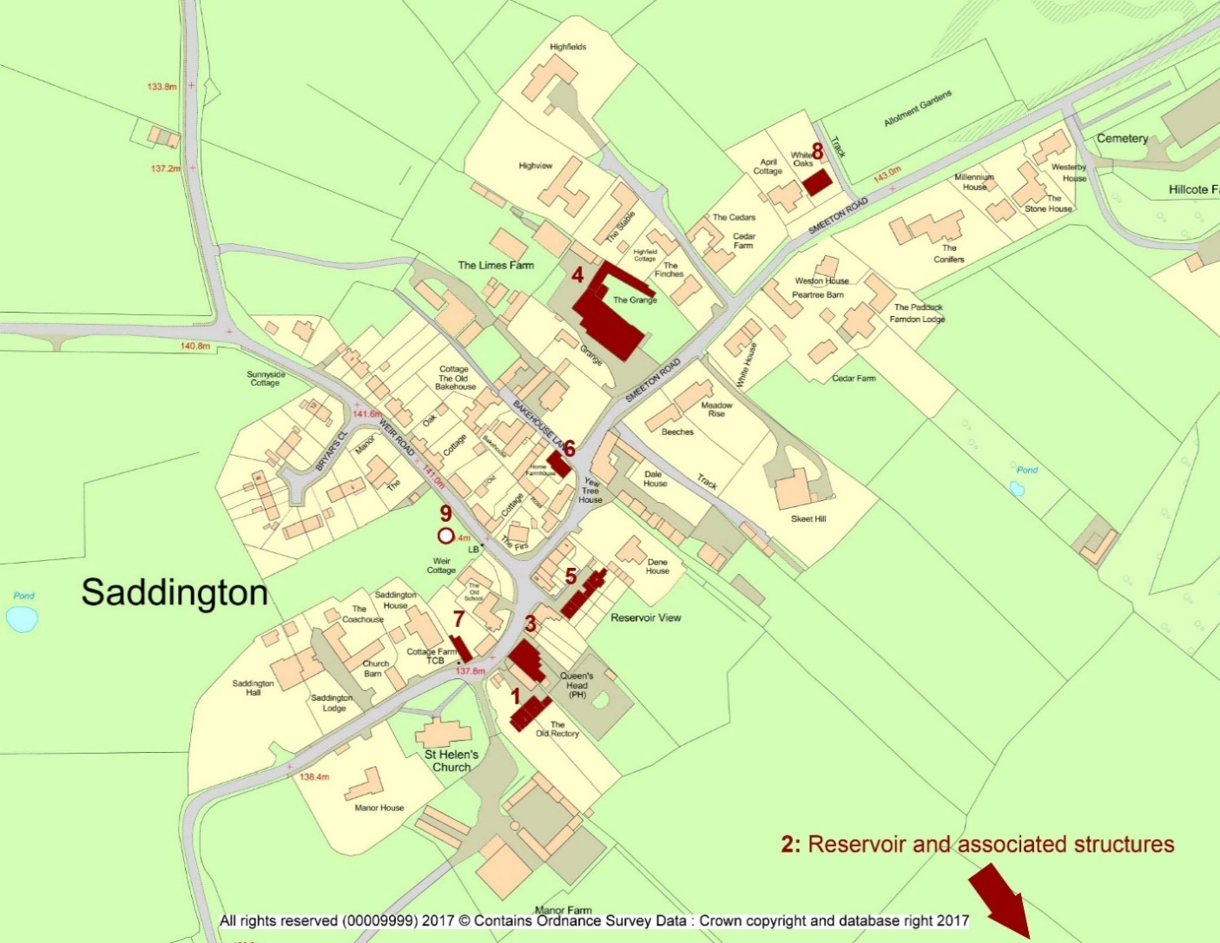
- The Old Rectory - On site of 1416 rectory Renovated over the years and recently converted into two dwellings

Saddington Reservoir
2a. Reservoir constructed 1797 as feeder for the Grand Union Canal.
2b. Tunnel constructed 1793 – 7, and is 883.6 yards (808m) long.
2c. Reservoir Island includes timber hut and landing stage (early 20th century) with local history associations.
- Queen’s Head public house - Original building c.1747, refurbishment c. 1847, renamed in honour of Victoria.
- The Grange - Previously Dalton House. An imposing building with unusual coach house with clock. Parts of the house date from late 18th century.
- Reservoir View - Four late 18th century cottages with views to the reservoir
- Home Farm, Bakehouse Lane 1890 - With a teagle hoist at first floor level for hoisting grain etc.
- Cottage Farm - Includes structural elements dating from 17th, 18th and 19th centuries.
- White Oaks, Smeeton Road - Previously the home of Peter Shilton between 1970 and 1975, goalkeeper for Leicester City Football Club between 1965 and 1975 and goalkeeper for England during the 1970s-90s.
- Village well - Recently rediscovered in ‘village green field’, Weir Road. Shown as ‘pump’ on 1903 Ordnance Survey map.

POLICY ENV 6: LOCAL HERITAGE ASSETS OF HISTORICAL AND ARCHITECTURAL INTEREST –
Development proposals that affect a non-designated building or structure of local historical or architectural interest identified in Appendix 9 or its setting will be expected to conserve or enhance the character, integrity and setting of that building or structure. The buildings are:
The Old Rectory
Saddington Reservoir
Queen’s Head public house
The Grange
Reservoir View
Home Farm, Bakehouse Lane
Cottage Farm
White Oaks, Smeeton Road
Village well
    - Ridge and Furrow
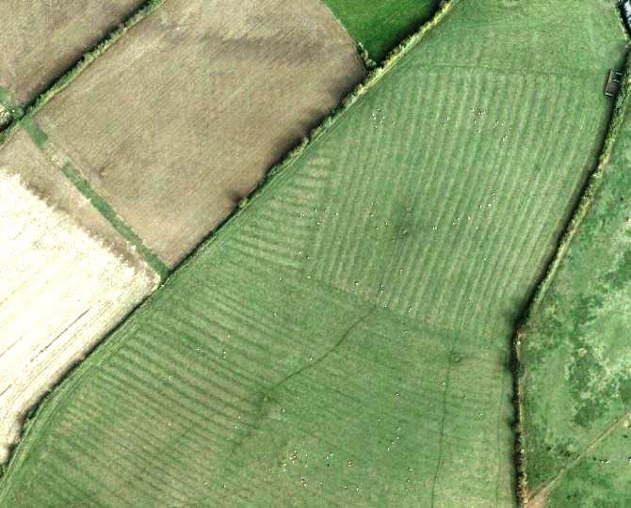
A characteristic and important feature of Saddington is the survival of a significant area of good quality ridge and furrow in the modern fields. The importance of Saddington in this regard has been recognised by Historic England (previously English Heritage) since 2001 (Hall, D 2001. Turning the Plough. Midland open fields: landscape character and proposals for management. English Heritage and Northamptonshire County Council), when the parish was included in an ongoing national research project, Saddington was then one of the top 43 parishes (classified as priority townships) out of some 1600 surveyed across the five English counties comprising the ‘planned landscape’ area of medieval open field farming. A local survey, using the same methods (aerial/satellite imagery and fieldwork), was done in 2017 as part of the Neighbourhood Plan process. This provides a record of the current situation.

“What was once common and often unregarded is now rare and needs to be valued.”
Graham Fairclough, English Heritage, 2001

Ridge and furrow southwest of the village in 2011. The fields top left, previously also part of this nationally significant heritage asset, were converted to arable between c.1997 and 2008 (Google Earth imagery)
The historical township of Saddington, with the village at its centre, was farmed using the open field system for nearly a thousand years from the Early Medieval Period until 1770, the date of its Enclosure Award. Cultivation was rotated on (usually) a 3-year basis and the land was managed communally. Ploughing was by ox-teams; the medieval plough was not reversible, meaning that as the land was ploughed (clockwise, up one strip and down the next) the soil was always thrown to the same side, forming ridges and furrows with a height difference of up to 2 metres. After the Enclosure, the fields were subdivided and almost all were converted to permanent grazing land, thus ‘fossilising’ all the features of the medieval farmed landscape, including the furlongs, headlands and baulks. A return to arable farming, using modern ploughs, during the late 20th century caused the destruction of most ridge and furrow across the Midlands. The national trend recorded in 2001 was a loss of between 85% and 100% per parish, most since 1940.
Based on comparison of the results of the 2017 fieldwork for this Plan with mapping carried out for the 2001 (see above) and 2012 (Catchpole, T and Priest, R, 2012. Turning the Plough update assessment. English Heritage and Gloucestershire County Council) studies, Saddington – previously one of the best-preserved in England – has lost a significant area of its ridge and furrow in the intervening 18 years, most (Google Earth historic imagery) between 1999 and 2011 (data normalised and converted to hectares):
 | Agricultural fields | Area, ha | With ridge and furrow | Area, ha | % by area
2001 | 160 | 656 | 55 | 293 | 45%
2012 | 160 | 656 | 51 | 262 | 35%
2017 | 160 | 656 | 50 | 261 | 34%
In English legislation ridge and furrow fields (except for the few that are also Scheduled Monuments) are not statutorily protected, despite a recognition that “as the open field system was once commonplace in NW Europe, these [surviving] sites take on an international importance” (English Heritage 2012. Project Brief for Turning the Plough Update Assessment). While individual fields in Saddington are not claimed to be of international importance, the well-preserved groups are important in their own right and valued by the local community; any further, avoidable, loss would be irreversibly damaging. Historic England strongly recommends treating all surviving ridge and furrow as non-designated heritage assets, and this is the approach taken in this Plan. The loss of more than one-fifth of what, in 1999, was judged by English Heritage to be an important historic environment feature nationally means that protection of what now remains should be a priority.
Because planning consent is not required for change of agricultural land use, the support of local farmers and agricultural landowners on a case-by-case basis will be necessary to achieve a sustainable balance between viable agriculture and protection of this apparently threatened historic environment heritage.

Figure 13: Surviving Ridge and Furrow in Saddington is a non-designated heritage asset
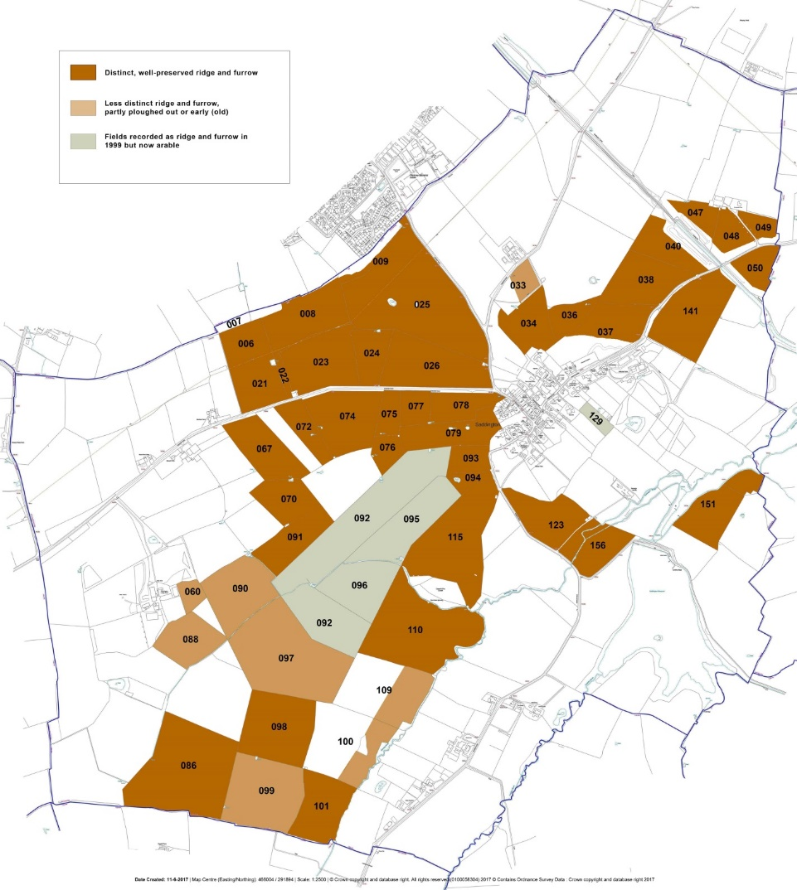

While individual fields in Saddington are not claimed to be of international importance (see above), the surviving well-preserved group is still important in its own right as a coherent, relatively complete record of England’s historic landscape and social history and is valued by the local community. Any further, avoidable, loss would be irreversibly detrimental. Historic England proposes treating all surviving ridge and furrow as a non-designated heritage asset, and this is the approach taken in this Plan.

POLICY ENV 7: RIDGE AND FURROW – The areas of ridge and furrow earthworks mapped above (Figure 13) are non-designated heritage assets.
Any loss or damage arising from a development proposal (or a change of land use requiring planning permission) is to be avoided; the demonstrable benefits of such development must be balanced against the significance of the ridge and furrow features as heritage assets.
    - Important Views
Consultation during the Neighbourhood Plan’s preparation identified a widely-held wish to protect Saddington’s rural setting, and its relationship with the surrounding farmland and the wider landscape, including its position in a gap between high ground to the west and east and the wide Welland valley to the south.
One of the main ways in which residents expressed this wish was by describing a number of highly-valued views within the village and toward it from the surrounding countryside. These consultation findings were supported by the environmental inventory, which although principally aimed at identifying sites of environmental significance also confirmed the sight- lines of the suggested views and mapped them. (See figure 14 below). The six principal views should be protected by careful siting of all development in the parish during the lifetime of the Plan.

POLICY ENV 8: IMPORTANT VIEWS – Development proposals should respect the open public views and vistas identified below and in figure 14:
- Public views south to northwest from field 093 and Mowsley Road/Saddington Hall at the western edge of the village over extensive open countryside.
- Public views northeast to east from field 026 into the village and over open countryside toward Fleckney in the north, mainly grassland with hedges and trees.
- Views east and southeast from various publicly accessible locations (including public house garden) over the valley of Langton Brook and an ornamental lake with wooded banks (parcel 136) and Saddington Reservoir (172) to the high ground marking the southern parish boundary.
- Panoramic public views northwest to east from field 037 into east Leicestershire, Northamptonshire, etc., over the canal and open countryside.
- Public views north and east from field 165 and Mowsley Road over the Langton Brook valley toward Saddington village (northwards) and the reservoir and open countryside (east).
- The public view southeast from footpath A.14 across valley meadows to the hillside incorporating fields 151 and 152.
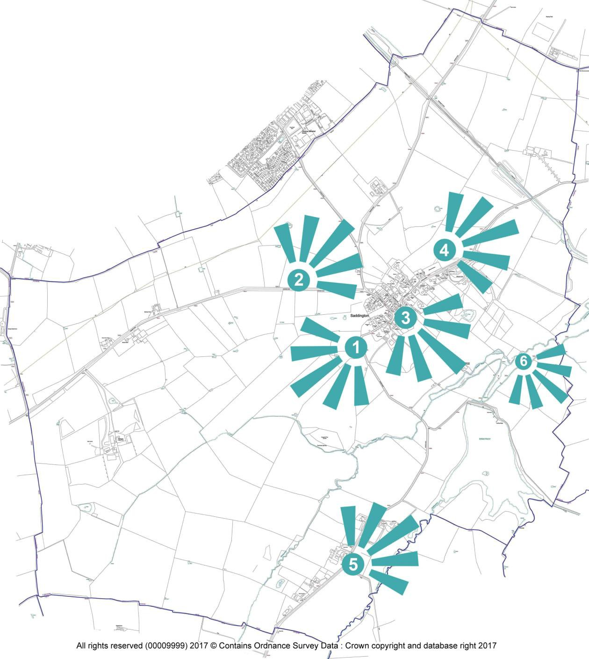
Figure 14: Important views.

Public Rights of Way
Several of the public rights of way in Saddington are ancient and historic ways linking the village to neighbouring communities and the open fields. They retain some of these functions today, providing social cohesion by connecting different parts of the parish and enhancing community wellbeing.
Saddington is characterised in part by its popularity for outdoor recreation. In addition to sailing and fishing, there is considerable local and visitor use of the parish for recreational walking; routes are publicised, with the rolling countryside and extensive views, and country pubs, being part of the attraction. So, while footpaths are no longer used for trade and communication they have an important 21st century role for recreation and leisure – by local walkers, more serious hikers, families, and people exercising pets. They provide direct connection with the environment, local history, wildlife and the landscape.
The Neighbourhood Area includes parts of National Cycle Network (Sustrans) route NC3. Cycle routes fulfil similar roles to footpaths in terms of community wellbeing (e.g. exercise, exploration, access to the countryside), but for a different demographic.
There are seven official footpaths, including a section of the long-distance waymarked Leicestershire Round, and one bridleway in the Parish. The towpaths of the canal are also important (although not formally rights of way) for the way they enable completion of circular, off-road walks around the eastern half of the parish.
All of these routes are well used by residents and visitors (high levels of respondents to the questionnaire/consultation use the local footpaths). It is important that they are maintained to provide safe and enjoyable access for all sections of the community. Residents appreciate the quality of the surrounding countryside and the benefit of being able to access it more easily.
Community consultation has highlighted some specific issues and ideas that can be addressed through the Neighbourhood Plan.
- The provision of a pedestrian pavement along the full length of Smeeton Road to give safer access to the cemetery and allotments around the bend in the road and repair of the verges along Smeeton Road to make them safe for pedestrian use.
- Improvement of the existing footpath routes to Fleckney and Kibworth (e.g. make it wider for easier use by all but especially for those with children in buggies or wheelchair users).
Proposals to enhance footpaths in the Parish are described in a Community Action in Section 8.

POLICY ENV 9: FOOTPATHS AND BRIDLEWAYS - Development proposals that result in the loss of, or have a significant adverse effect on, the existing network of footpaths and bridleways will not be supported.
The maintenance, upgrade and, where appropriate, extension of the pedestrian footpath network in the Parish will be supported in order to:
- Service new developments and connect them to the existing pedestrian footpath network;
- Encourage walking instead of car use for making journeys within the parish; and
- Provide an improved and more extensive footpath network to support exercise and leisure activities for Saddington residents and visitors as stated in policy CF2
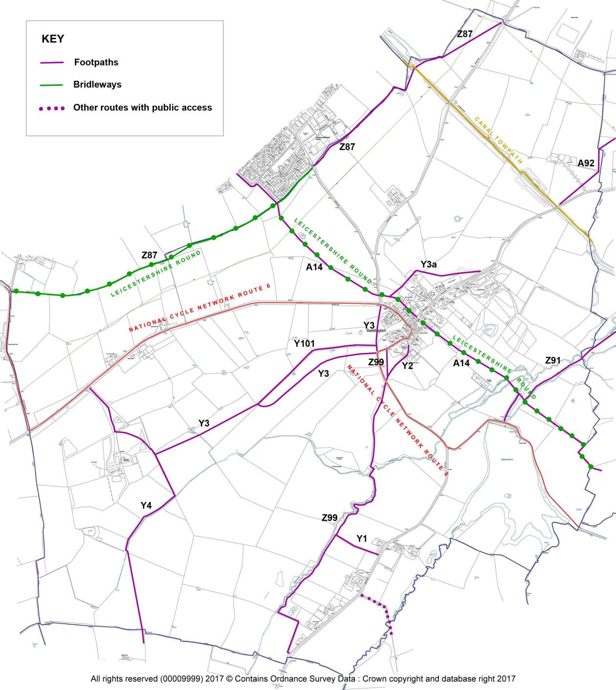
Figure 15: Rights of Way in Saddington

    - Flood Risk
The village of Saddington is at no risk of flooding from main rivers, although it is noted that the narrow floodplains of Saddington and Langton Brooks, and the area immediately surrounding Saddington Reservoir, do flood as part of the natural, seasonal and weather- driven, behaviour of rivers and water bodies.

POLICY ENV 10: FLOODING - Every development proposal of appropriate scale and where relevant will be required to demonstrate that:
- The development and its occupants are safe from flooding for its lifetime;
- Its location takes geology, hydrology and flood risk into account, including undertaking a hydrogeology study whose findings must be complied with in respect of design, groundworks and construction;
- Its design includes, as appropriate, sustainable drainage systems (SuDS), surface water management measures and permeable surfaces; and
- It does not increase the risk of flooding to third parties.

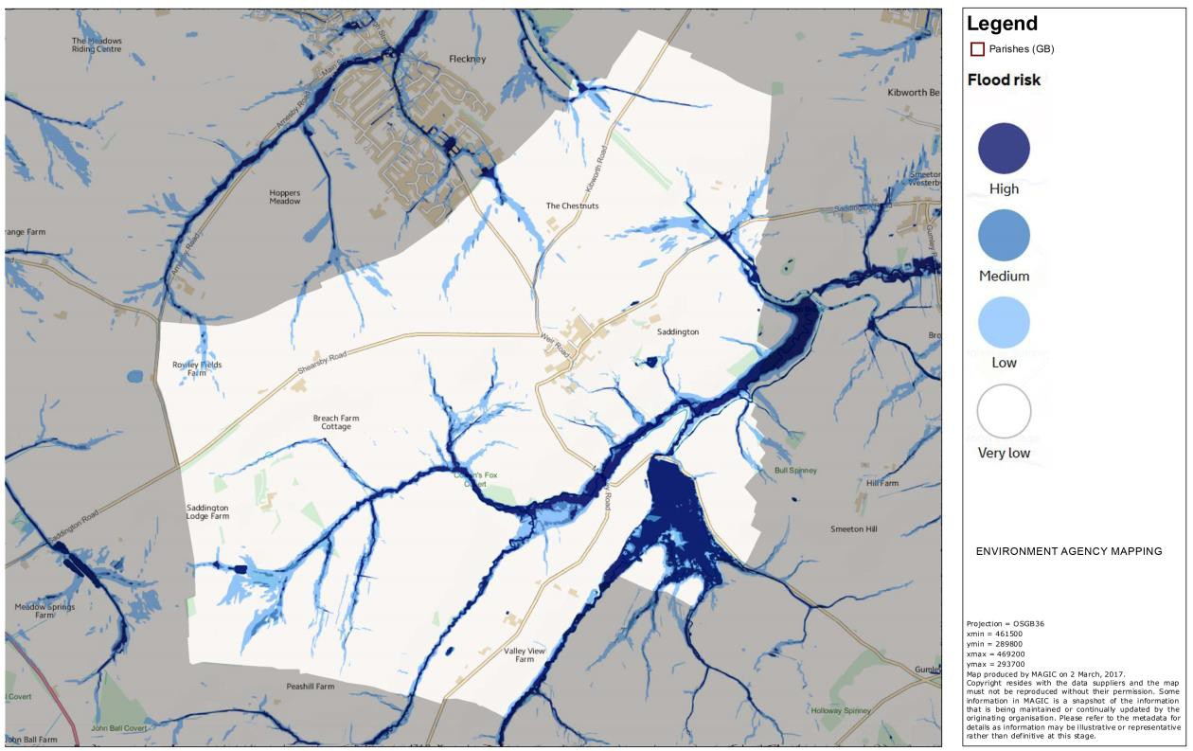
Figure 16: Flood risk (rivers and surface water) in Saddington village: Environment Agency mapping

The principal concern here, as elsewhere in England, is the greater frequency and intensity, both observed and predicted, of flooding by surface water. Any future development, whether large scale or individual, should bear this in mind at the planning stage. Mitigation of the causes and effects of climate change are part of English Planning policy, and the residents of Saddington wish to play their part in achieving the objectives of Harborough District Council’s relevant policies at the Neighbourhood Plan level.
In particular, it is noted that future development of sites in the part of Saddington parish immediately south of the Fleckney built-up area will encroach on several areas at risk of flooding by surface water from a number of ordinary watercourses (ditches, seasonal streams).

Renewable Energy Generation Infrastructure and related matters
The National Planning Policy Framework (paragraph 97) emphasises that all communities are responsible for reducing emissions. Although paragraph 97 is specifically directed at Local Plans, Neighbourhood Plans like this one have their own part to play, and residents of Saddington are keen to promote both appropriately-scaled technologies for ecologically sound energy generation and appropriate measures to reduce energy consumption.
With regard to wind turbines, the Landscape Sensitivity to Renewable Energy in Harborough District Study (July 2016), conducted to inform the emerging Local Plan, identified landscape sensitivity areas (coinciding with Harborough District’s Landscape Character Areas (LCA’s) which are more detailed than the LCAs used by Natural England) for planning the location of renewables infrastructure. Saddington straddles the Laughton Hills and Lutterworth Lowlands LCAs (most of the parish is in the former, with only the fields south of Fleckney being in the latter). The Laughton Hills LCA is judged to have only ‘limited capacity’ for accommodating renewable infrastructure. The Lutterworth Lowlands LCA is ‘characterised by man-made features’ and judged to be suitable for accommodating ‘large-scale renewable energy, including commercial windfarms’, but the segment within Saddington parish is clearly overlooked from, and draws much of it character from, the Laughton Hills part of the parish. Any large-scale turbine development here would be severely detrimental to Saddington’s landscape.
Small turbines (e.g. below 30m to blade tip) may be capable of being accommodated in some locations within the Laughton Hills LCA, but only where it can be demonstrated that there is no adverse landscape or public amenity impact. Similar criteria should also be applied in respect of large - (‘solar farms’) and small-scale solar panel/PV installations
Saddington’s rural character, and its location at some distance from the night-time glow of Leicester, Lutterworth and Market Harborough, means that residents wish street lighting in the village and other built-up areas to kept to the minimum required for safety, in order to reduce energy consumption and to maintain the existing level of ‘dark sky’ in the parish. Refer to Policy H8.

POLICY ENV 11: ENERGY GENERATION AND CONSERVATION – Development that incorporates environmentally sound energy generation and/or storage technologies will be supported.
Large scale wind turbines and solar farms are not appropriate in the Laughton Hills Landscape Character Area or in the small part of the Lutterworth Lowlands Landscape Character Area between Saddington and Fleckney.
Proposals for small-scale renewable energy generation and energy storage facilities will be considered favourably, on their merits, providing that conditions regarding habitats and species, heritage assets, landscape character, noise and visual impact are in place.
  - Community facilities and amenities
    - Introduction
Community Facilities & Amenities play an important part to life in Saddington, they help to bring the community together and to make us collectively proud of our home Parish.
As a small rural parish, consisting of some 95 dwellings, including 6 working farms, there are only a few Facilities and Amenities within Saddington, so it is important that the village retains what Facilities & Amenities it does have. Some of these provide local employment and also a reason for visitors to come to Saddington, be it to see residents or visiting as tourists.
The Public House and the Church are the two main focal points for the community gathering together, especially as there is no village hall or shop.
What Saddington does have aplenty is beautiful surrounding countryside, with interesting features. Set in the countryside of south Leicestershire, ten miles south of Leicester and seven miles north of Market Harborough, the village appears in the Domesday Book of 1086 as Setington. It is a hamlet of the Gartree Hundreds and was once a gated village.
Built on a hilltop, surrounded by rolling countryside, it overlooks the reservoir to the south, constructed between 1793 - 1797 to supply water to the Grand Union Canal, which runs within the boundaries of the Parish. Navigating the canal to the north will take you towards Leicester, to the south will take you to Foxton with its famous flight of locks. Part of the canal runs through the half mile long Saddington tunnel, which is especially noted for being inhabited by bats!
Saddington has a good network of footpaths across the fields, including part of The Leicestershire Round, which cuts right through the middle of the village. The Leicestershire Round is a 100 mile walk along footpaths around Leicestershire.
The Guthlaxton trail cycle route also passes through Saddington. This is the section of National Cycle Network route 6.
The importance of the existing facilities and amenities were highlighted in the consultation events that have taken place across the Parish during the preparation of this Neighbourhood Plan.
In the Neighbourhood Plan Community Questionnaire that was conducted as part of the consultation process, those responding valued highly the separation of Saddington from other villages and also open countryside surrounding the houses in the village and the fact that much of the open countryside is made up of working farmland.
The community consultation questionnaire identified the importance to parishioners of traditional features such as the village pub and church. It also highlighted the wish to increase and improve community facilities such as a village hall (currently the church is used for parish and other village meetings) and a village green – something that the community is working hard to develop in 2017.
Responses to the questionnaire also showed a desire to improve the accessibility and natural beauty of the parish with an enhanced network of footpaths and more trees.
    - Protecting existing community facilities and amenities

St. Helen’s Church
The church of St. Helen has stood in the village in some form or other since the 12th century. The ﬁrst recorded rector was William de Bubbenhill who was the incumbent from 1186 to 1209.
A grade 2 listed building constructed from limestone and ironstone with a Welsh slate roof. the building has evolved over the centuries with substantial additions in the 13th and 14th centuries - it has a 14th century font. By 1627 the church had fallen into serious disrepair with records stating that ‘Cattle and hogs came in and uprooted the graves of dead bodies interred there. Windows were broken letting in birds and rain’. In 1662 the chancel was said to be ‘utterly ruined’ apparently damaged by ﬁre and intruders. Gradually during the 18th and 19th centuries the church was restored and in 1872/3 the architect Frederick Peck supervised the complete rebuilding of the old church.
When the village school closed in 1976 the village lost not only a school but also a valuable meeting room. There is no village hall in Saddington, so further internal changes were made to the church in the 1980’s when the pews at the back of the church were removed to create an open, usable space with a kitchen area, allowing various village activities and functions to take place.
In more recent times toilet facilities have been installed allowing for greater ﬂexibility in the use of the church. Extensive re-rooﬁng work was carried out in 2013. St. Helen’s belongs in a beneﬁce with St. Wilfrid’s in Kibworth and Christchurch in Smeeton Westerby. At the present time, the church offers two regular services a month, weddings, christenings and funerals as well as special services to celebrate festivals such as Christmas, Easter and Harvest. There is a small but dedicated congregation. The church beneﬁts from having a peal of 6 bells and an active band of bell ringers.
Members of a small table tennis club play at the back of the church. The meeting area has been used for Harvest Suppers, Barn Dances, Royal Event celebrations (e.g. Queen’s Jubilee and Royal Weddings), Flower and Produce Shows, and various fundraising events take place, including dances and musical performances. For the past 30+ years, Sunday afternoon tea and cakes are served during the summer months. Parish Meetings take place and more recently the church has been used as a polling station. The church yard is now closed for burials and a District Council run cemetery is sited on the north-east side of the village.

Village events
Saddington organises a good range of village events, many centred around the church, illustrating its value as a community hub as well as a place of worship. Villagers helped to finance the building of the toilet to allow for such events.
Parish events which currently take place are the Harvest Supper, cheese & wine, Safari Supper (where parishioners move between homes for each course of their supper), monthly drinks at pub for residents to meet & chat, litter picks, bulb planting groups, sailing club events, street parties and Open Gardens weekends.
A Community Action (Section 8) seeks to promote and enhance the range of village events.

Riding schools and liveries
Saddington is popular with horse riders and the riding school is a good place from which to start.
Saddington Riding School and Livery Stables, based at Manor Farm, has been established for over 30years. The current proprietor has been there for 5years.
Situated to the south of the village it overlooks the reservoir and across to Gumley woods. It attracts a lot of visitors to the village, who come to enjoy the various riding activities offered.
The school provides lessons and hacking sessions for all age groups and abilities. They also offer 'Pony parties', 'Pony days' and 'Pony camp'. The school owns over 20 horses and also provides livery stabling.
The Livery also attracts not only villagers but people from outside to stable their horses and also to enjoy the countryside whilst out hacking.

Care Home
The Parish has a privately-owned nursing home, The Grange Nursing and Residential Home. The Grange provides accommodation and nursing care for up to 50 people with health conditions and physical and sensory needs including dementia.
Accommodation is arranged over two floors with 46 single rooms, 2 shared rooms and 16 rooms with en-suite WC, there is also a passenger lift to assist people to get to the upper floor, and there is car parking provision on-site.

B&B Accommodation
Situated on the north-east side of the Parish, close to the canal on the road to Smeeton Westerby visitors can stay for Bed & Breakfast at one of the working farms. The proprietor of the B&B has long term plans to build log cabins to rent out for holidays. These would be situated in a ﬁeld bordering the canal on the opposite side to the tow path.

Camping and caravan site
On the road to Mowsley, close to the reservoir is Barford Top Campsite & Caravan Park, which was established approximately 4years ago. It provides pitches (including hardstanding) for 5 caravans and 10 tents, as well as pitches for motorhomes.
The site has good facilities including; showers, toilets, cookers and a dining room. It has received good reviews from people who have stayed there. The site boasts wonderful views and is a good starting point for walkers and visitors wanting to visit other places of interest in the local area.

The Queen’s Head Public House
A pub provides an important role in a village community. It provides a focal point, helps bring together members of the community who may not otherwise interact, as well as contributing to the local economy.
There has been an Inn at Saddington since at least 1747, although as this was called 'the New Inn' it is likely that it existed for some time before that.
Early records show that in March 1747 the Inn paid out to Henry Smith for ale at the stint. (a stint was a measured length of repair to the road carried out by parishioners who could not afford to pay their rates.)
By 1846 the Inn was called the Queen's Head. The name was probably changed when Queen Victoria came to the throne in 1837.
The pub/ restaurant is an Everards pub, and since 2013 has been managed and co-owned by Chris Lewis Sharman. The premises underwent a renovation in 2013 by Everards after previously being run as an Indian restaurant/pub.
The restaurant, which has 60 covers, is in a modern extension which has far reaching views of the reservoir, and beyond the restaurant there is a large garden including a play area.
The Sunday lunches are popular, and the pub holds occasional barbecues, and has a bouncy castle for children during part of the summer
The Farm Shop which had been run from the back of the premises closed in 2017, meaning that there is no longer any form of shop in the Parish.

Allotments
Saddington is one of six allotment sites located around the Harborough district. There is a waiting list in operation for all the sites and as at October 2017 Saddington’s wait time was approximately 4 years.
In some cases when plots become available the council are halving the size to enable more people to enjoy the benefits.

The Reservoir
Situated to the south of the village, the reservoir is home to Saddington sailing club, who own a small clubhouse. Members are made up of enthusiastic sailors with novice to experienced sailors. New members are always welcome. Sailing days at the club are held on Sundays throughout the summer.
The reservoir is also a popular location for fishermen and there is a small fishing club. The reservoir and beyond is home to a variety of wildlife and is popular with walkers and horse riders alike.

Village Green
A parcel of land situated on Weir Road in the middle of the village, was gifted to the village by Mr Steve Short, a long-time Saddington resident in 2017 for development for use as a village green.
The Village Green is owned by Saddington Parish Meeting on behalf of the residents of Saddington village, and the land is held in trust by the Parish Trustees of Saddington who are the Chairman of the Parish Meeting and the Proper Officer of Harborough District Council. The Parish Trustees act in accordance with the directions given by the Parish Meeting.
Saddington Village Green is managed by a Management Team who act on behalf of, and in accordance with the wishes of, Saddington Parish Meeting. The Village Green Management Team manage and maintain the Village Green on behalf of the residents of Saddington village for the collective good of the village, and represent the interests of the residents of Saddington.
A Community Action will seek to ensure that the use of the Village Green is maximised.

Public benches
There are 4 public benches sited around the village; one at the top of Weir Road at the junction with Shearsby Road, one on the road to Mowsley, one on the small triangle of grass in the centre of the village at the junction of Weir Road and Main Street and one situated at the back of the church overlooking the reservoir. The bench at the end of Weir Road is often used by walkers and cyclists, the one in the centre of the village is regularly used by walkers. One on the road to Mowsley is rarely used, now that there is no view. The one behind the church is used when the Church teas are on.
A Community Action (Section 8) will ensure that the public benches remain in the most appropriate locations and are maintained in a safe condition.
Both the NPPF and the draft Harborough Local Plan indicate that valued community facilities should be retained. Policy CF1 supports the objective of maintaining an adequate level and range of facilities.

Policy CF1: THE RETENTION OF COMMUNITY FACILITIES AND AMENITIES - Development
leading to the loss of an existing community facility or amenity, including St Helen’s Church, Queen’s Head pub, Allotments, Village Green, The Grange Residential and Nursing Home, Barford Top Camping and Caravan Site, and the Riding School and Livery will not be supported unless it can be demonstrated that:
- There is no longer any need or demand for the existing community facility; or
- The existing community facility is no longer economically viable; or
- The proposal makes alternative provision for the relocation of the existing community facility to an equally or more appropriate and accessible location within the Parish which complies with the other general policies of the Neighbourhood Plan.
    - Promoting additional community facilities and amenities
Community consultation confirmed the importance of enhancing the number and variety of community facilities and amenities in the Parish, recognising their value to the local community.
Community Actions (Section 8) will seek to develop and improve local facilities and to ensure that they are fully accessible for people with disabilities.
Concern was expressed amongst the community through the consultation process about inadequate car parking facilities in the village, as well as increasing levels of traffic, particularly cars and light commercial vehicles, through the village and any expansion to local services would need to take this into account given the nature of the rural road network.

POLICY CF2: NEW OR IMPROVED COMMUNITY FACILITIES - Proposals that improve the quality and/or range of community facilities, will be supported provided that the development:
- Will not result in unacceptable traffic movements or other disturbance to residential properties;
- Will not generate a need for parking that cannot be met;
- Is of a scale appropriate to the needs of the locality and conveniently accessible for residents of the village wishing to walk or cycle; and
- Fully takes into account the needs of people with disabilities.

  - Businesses and employment
    - Support for existing employment opportunities
The strength of the local economy and of the community goes hand in hand. Supporting the growth of a stronger local economy is recognised as an important theme of the Neighbourhood Plan. However, Saddington is a rural parish relatively distant from the major employment centres. Employment opportunities within the Parish are therefore limited in scale.
That said, there is an increasing trend for residents to work from home with 18% of people responding to the community questionnaire said that they either operate a business in the Parish or work from home. Types of business that are either registered with a Saddington address or are operated within Saddington include: farming, project management services, public house, contract cleaning, building and property services, beauty treatment, Nursing Home, car restoration, the administration of a medicaolegal reporting and Alexander Technique tuition business; bed and breakfast, and a campsite. With improving IT connectivity locally and changing employment patterns nationally, this trend is likely to continue.
For the majority of workers resident in the Parish the lack of significant employment opportunity means that their only option is to work away from the area, commuting increasingly greater distances to secure employment. This impacts particularly on young people for whom the high property values combined with the lack of local employment opportunities make Saddington a difficult option for residence.
There are very few employment opportunities within the parish outside of the local businesses, pub and farm-related activities.
Where there are buildings that are dedicated to business use in the Parish it is recommended that they be protected against being lost to other uses.

Policy BE1: SUPPORT FOR EXISTING EMPLOYMENT OPPORTUNITIES - There will be a strong presumption against the loss of commercial premises or land (B-class) which provides employment or future potential employment opportunities. Applications for a change of use to an activity that does not provide employment opportunities will only be supported if it can be demonstrated that:
- The commercial premises or land in question has not been in active use for at least six months; and
- The commercial premises or land in question has no potential for either reoccupation or redevelopment for employment generating uses and as demonstrated through the results both of a full valuation report and a marketing campaign lasting for a continuous period of at least six months.
    - Support for new employment opportunities
New employment initiatives in the right location can help to boost and diversify the local economy and to provide more local employment opportunities.
Within the community questionnaire a large minority (44%) said they would welcome new businesses into the village. There is however a common theme of any new employment initiatives being sensitive to the character of the Parish and employment proposals should only be seen as acceptable if they avoid harmful impacts on other matters agreed to be locally important such as increased traffic flows, parking, residential amenity, the preservation of historic/heritage assets and the local environment.
Though consultation views were mixed on the provision of new employment opportunities in the Parish. The views expressed suggested there would be no objection to development appropriate to the rural nature of the village and the Parish. However, there was significant opposition to any larger scale business development, citing reasons such as the inability of the roads to cope, increased traffic flows and it not being good for a small village.
There is, however, a need to recognise and support the increasing numbers of people who conduct their businesses from home. The Neighbourhood Plan reflects this in its proposals to provide a wider range of housing and to support the provision of local business premises where appropriate.
The Harborough Core Strategy supports the rural economy by allowing for new employment land to be provided, helping create or safeguard jobs.

Policy BE2: SUPPORT FOR NEW EMPLOYMENT OPPORTUNITIES - In supporting additional employment opportunities, new development will be required to:
a) Fall within the boundary of planned limits of development for the village of Saddington unless it relates to small-scale leisure or tourism activities, or other forms of commercial/employment related development appropriate to a countryside location or there are exceptional circumstances;
b) Where possible, development should be sited in existing buildings or on areas of previously developed land;
c) Be of a size and scale not adversely affecting the character, infrastructure and environment of the village itself and the Neighbourhood Area, including the countryside
d) Not involve the loss of dwellings
e) Not increase noise levels or light pollution or introduce any pollution to an extent that they would unacceptably disturb occupants of nearby residential property
f) Will not result in unacceptable levels of traffic movements that generate increased levels of noise, fumes, smell or other harmful disturbance to residential properties including the need for additional parking which cannot be catered for within the curtilage of the property;
g) Contribute to the character and vitality of the local area; and
h) Be well integrated into and complement existing businesses. The following types of employment development will be supported:
- The small-scale expansion of existing employment premises across the Parish;
- Small-scale new build development within or adjacent to Saddington village.
    - Home working
In rural areas such as Saddington with limited employment opportunities the benefit of supporting home working is that it helps to promote employment activities whilst reducing the dependency of the car for journeys to employment sites outside the Parish.
Currently some 18% of the village inhabitants work from home (full-time or part-time) or are employed by a local business, a little more than the national figure of 14% and rising trend indicated by the Office for National Statistics.
The intention of Policy BE3 is to recognise that people may not have a suitable space within their home from which to run a business, or they may wish to separate their work distinctly and deliberately and living space. Policy BE3 supports the construction of extensions, the conversion of outbuildings, and the development of new freestanding buildings in gardens from which businesses can operate. This is intended to maximise the opportunity for home run enterprises to be created and supported in the long term in Saddington.
Policy E3 would apply where a material change of use occurs, such that planning permission is required. This reflects positive support for entrepreneurial activity in line with the NPPF and draft Harborough Local Plan.

POLICY BE3: WORKING FROM HOME - Proposals for the use of part of a dwelling for office and/or light industrial uses, and for small scale free standing buildings within its curtilage, extensions to the dwelling or conversion of outbuildings for those uses, will be supported where:
- Such development will not result in unacceptable traffic movements and that appropriate parking provision is made
- No significant and adverse impact arises to nearby residents or other sensitive land uses from noise, fumes, light pollution, or other nuisance associated with the work activity; and
- Any extension or free-standing building shall be designed having regard to policies in this Plan and should not detract from the quality and character of the building to which they are subservient by reason of height, scale, massing, location or the facing materials used in their construction.
    - Farm diversification
There are 6 working farms in the Parish - two sheep farmers, one cattle & arable farmer, two cattle & sheep farmers and one cattle, sheep and arable farmer.
There has been some farm diversification: one farm has business units and a wind turbine; one has a bed & breakfast, and has had a solar farm rejected but is now planning to have an energy storage system installed. Another has a log business and Saddington Car Boot Sale on his land. Finally, another has a livery in Saddington and also has a wind turbine that is located outside the parish on their other land. Other than the possibility of one planning log cabins in the future we are not aware of any other diversification plans currently.
There is general support for farming diversification. The conversion of former agricultural buildings could enable diversification and lead to the sustainable re-use of vacant buildings providing opportunities for the establishment and development of small businesses which generate income and employment opportunities for local people. This is a trend which the Parish Meeting would like to continue in the Neighbourhood Area to maintain a balanced and vibrant community, subject to the proper consideration of residential amenity for nearby houses, visual or other impact on the countryside and highway safety issues. The movement towards using farmland for alternative business sites has also been seen in the Parish with a planning request for a Solar Farm which didn’t progress followed by a new planning application for land to be used as a battery storage facility.
Specifically, this support for farming diversification is intended to:
- Promote a viable and sustainable farming and rural economy in Saddington Parish
- Promote the diversification of rural businesses
- Encourage new businesses to provide a wider range of local produce, services and leisure facilities, to provide local employment and attract visitors to the Parish
- Maintain and enhance the local environment of rural and agricultural land
The change of use of some rural buildings to new uses is already permitted under the General Permitted Development Orders. The Town and Country Planning (General Permitted Development) (Amendment and Consequential Provisions) (England) Order 2014 allows, under certain circumstances, the change of use of agricultural buildings to residential use and change of use of agricultural buildings to registered nurseries providing childcare or state- funded schools, under the prior approval system.

POLICY BE4: RE-USE OF AGRICULTURAL AND COMMERCIAL BUILDINGS - Notwithstanding
permitted development rights granted by the Town and Country Planning (General Permitted Development) (Amendment and Consequential Provisions) (England) Order 2014 or any subsequent amendment, and, in order to support farm diversification and the sustainable growth and expansion of businesses, the conversion of existing agricultural and commercial buildings will be supported subject to:
- The use proposed is appropriate to the rural location;
- The conversion/adaptation works respect the local character of the surrounding area;
- The development will not have an adverse impact on any archaeological, architectural, historic or environmental features;
- The local road system is capable of accommodating the traffic generated by the proposed new use and adequate parking can be accommodated within the site;
- There is no significant adverse impact on neighbours through noise, light or other pollution, increased traffic levels or increased flood risk.
    - Tourism
Saddington is a beautiful rural parish to which walkers and other visitors are attracted, areas of interest include the reservoir with its fishing and sailing, local canals, the Guthlaxton trail cycle route and the Leicestershire Round walking route which cuts through the Parish. The Parish is keen to extend a welcome to visitors whilst ensuring that their visit has a positive impact on parishioners - for example, in the context of traffic.
There is much in the village for visitors to enjoy, with stables, livery, reservoir for sailing and fishing, walking, including the Leicester Round.
The Fernie Hunt is also a tourist attraction. The only one of the five Leicestershire hunts to be contained entirely within the county, and can trace its history back to 1853 when the "Billesdon Country" was separated from the rest of the Quorn Hunt. The hunt has a large following and on some of the hunt days will cross much of the Saddington countryside with horse and hounds.
Another significant tourist attraction is Saddington Car Boot Sale. This has been organised by Gary Dilkes since 1992. It is the largest car boot sale in Leicestershire with over 500 car booters regularly attending. The car boot sale is held on 28 days of the year (weather permitting) from March to October.
It is felt that the tourist offer to visitors can be enhanced over the lifetime of the plan.

POLICY BE5: TOURISM - Development proposals for tourism and leisure facilities will be supported within or adjoining Saddington, on a scale appropriate to the settlement, where it:
- Does not have a detrimental effect on the distinctive rural character of the Parish;
- Does not have a significant adverse impact on the surrounding infrastructure, particularly local road networks and water supply and sewerage;
- Benefits the local community, through for instance, provision of local employment opportunities and improvements to local service provision, and is proportionate to the size of settlement in which it is located; and
- Where feasible, the development involves the re-use of existing buildings or is part of farm diversification.
The net loss of tourism and leisure facilities will not be supported unless they are no longer viable or alternative provision is made available.
    - Broadband infrastructure
Concerns about the broadband and mobile phone signals in the parish featured prominently in community consultation. As in other rural areas, where many work from home and a lack of public transport can mean that some older people become isolated, communication technology is important.
The modern economy is changing and increasingly requires a good communications infrastructure as a basic requirement to maximise technological advances. High-speed Internet connectivity is driving business innovation and growth, helping people access services and opening up new opportunities for learning. This is particularly important in small rural settings where better broadband enables improved access to an increasing number of on-line applications and services provided by the public and private sector, can help to reduce social exclusion and create business opportunities.
84% of those responding to the questionnaire felt that their broadband and their mobile phone reception (79%) required improvement. Additionally, just as few would have predicted the technological transformation of the past few years, there will undoubtedly be further advances in the future. It is crucial that Saddington is able to accommodate and deliver new technology as is arises. The need for further development of high-speed broadband infrastructure to serve Saddington Parish as technology develops is very important, this could include investigating alternative methods of broadband provision such as Fixed Wireless Access.

POLICY BE6: BROADBAND INFRASTRUCTURE - All new developments should have the necessary ducting and infrastructure within the site and building(s) so as to be able to connect to superfast broadband.
Proposals to provide access to a super-fast broadband service (including future developments at present unforeseen) and improve the mobile telecommunication network that will serve businesses and other properties within the Parish will be supported.
This may require above ground network installations, which must be sympathetically located and designed to integrate into the landscape and not be located in or near open landscapes.

  - Transport
    - Traffic management
Saddington is small rural parish with the village sitting on the top of a hill between the A6 Market Harborough to Leicester Road and the A5199 Leicester to Husbands Bosworth road, surrounded within a few miles in each direction by the villages of Mowsley, Fleckney, Smeeton Westerby and the Kibworths. It is regularly used as a short cut to access other main routes to the M1, M6, and M69. Roads through the Village are covered by a 7.5-ton weight limit (except for access) which unfortunately is not always observed.
The development of the Village largely predates motor transport which leads to parking issues and traffic problems along Weir Road, Smeeton Road and Main Street especially in the centre of the village.
There is currently a regular public transport provision from Market Harborough to Fleckney through the village and during school term times several buses (double deckers or luxury coaches) are used to convey the children to the local junior and secondary schools and other colleges. There can be as many as four such vehicles passing through the village at any one time.
For most people living in the parish, however, the car has become the principle mode of transport even for the shortest of journeys.
The NPPF encourages a reduction in congestion and greenhouse gas emissions through the introduction of measures which promote a reduction in the number of journeys made by car, and there are a number of actions that can be taken by individuals and by the public and private sectors to support this objective.
The Plan, therefore, focuses on those areas where it can have an influence on the need to travel by car, highway safety and parking provisions. In particular it includes measures to promote new areas for parking and ensures that, where necessary, traffic management measures are provided in connection with new development.

Parking and traffic congestion
Concern was expressed amongst the community through the consultation process about inadequate car parking facilities in the village, as well as increasing levels of traffic, particularly non-resident vehicles and light commercial vehicles, through the village and any expansion to local services would need to take this into account given the nature of the rural road network.
Several policies in the Neighbourhood Plan support the aim of improving the transport situation in the Parish. These include supporting the provision of new pedestrian links to the surrounding areas (Policy T2); reducing the reliance on vehicles through the support for additional employment opportunities and home working (Policy BE3); supporting the promotion of high speed electronic communications, enabling businesses and individuals to communicate more effectively without travel and providing the opportunity for residents to work at home and more locally (Policy BE4); and providing an appropriate level of off-road parking in any new development (Policy T1).
Traffic congestion, however, remains an issue throughout the village. It is particularly bad during the morning and evening rush hours and school run times but, some areas of the village such as the junction of Weir Road and Main Street see frequent blockages because of both the volume and size of the vehicles and the inconsiderate parking. This area is often inaccessible to delivery vehicles and could potentially cause problems for emergency vehicles because of the number of vehicles parked around the junction.
Policies T1 – T2 aim to limit the harm that new development could have on traffic congestion and parking within Saddington. Community Actions will ensure a review of the options for improvement of car parking facilities within Saddington and also the options for enforcement of areas where parking is considered to be dangerous. This is covered in Community Actions in Section 8.
With the advent of the reliance of satellite navigation systems many HGV's are passing through the village and having to mount the pavements to get around parked vehicles, which also cause problems for the resident farm businesses with their increasingly large but necessary agricultural vehicles.
One identified solution to the traffic congestion in the village is a review of the number and size of the buses picking up/dropping off school children.
We do not want to see double yellow lines throughout the village as this will harm the character of Saddington. Other ways to encourage residents and visitors to park considerately and safely will be explored through a Community Action (Section 8).

Electric Vehicles
Over the lifetime of the plan there will be a major shift in motor vehicle technology as electric vehicle technology supersedes the existing petrol and diesel-powered vehicles. The UK as a whole has to address a major upgrade in infrastructure to generate and distribute the additional electrical power that is needed to charge the batteries of the electric vehicles. At a local level, every house that owns an electric vehicle will have to address how the vehicle will be re-charged – either at a remote station or at the home location. Saddington supports the introduction of green energy technology, and Saddington will have to prepare for electric vehicles and address the issue of how cars can be re-charged either at off-road locations; and for those houses that do not have the option for off-road charging. It is possible that charging points may have to be installed at roadside locations.
Any new housing development should include infrastructure and available power supply that will support charging of electric vehicles that are parked at each house.

Traffic calming/safety for pedestrians
Speeding through the village is considered by parishioners to be an issue. 66% of those responding to the questionnaire believe that a change is needed in order to reduce speeds through the village before a serious accident occurs. Smeeton Road is a particular problem (with some of the narrowest roads in the village).
The junction of Weir Road and Main Street is a problem because of the narrow roads, parking hazards and the erosion of the give way markings, highway edging and centre white line (the latter throughout the village were previously marked in Weir Road, Main Street and Mowsley Road). Alterations at the junction by the reduction of the footpath to widen the road where Main Street runs towards Smeeton would help the larger vehicles get around and reduce the parking hazard.
The pedestrian footpath leading to the allotments and cemetery could be continued from Cedar Lodge to April Cottage which would give access to the parking by the allotments, and the grass verge adjacent to the allotments is in serious need of repair to make it safe for pedestrians to use. The pedestrian footpath along Smeeton Road could be extended to improve pedestrian safety for access to the allotments and the cemetery. The grass verge in front of the allotments is in serious need of repair to make it safe for pedestrians to use.
All existing roadside footpaths in the village could be safe for pedestrians to navigate if road- users would observe the Highway Code, in particular when parking close to junctions and bends in the road and not parking on the pavements.
Parking on pavements is rife as cars owners attempt to free the narrow roads and protect their cars from damage – at the expense of pedestrians.
At school run times, increased vehicles volumes and bus traffic using the village as a short route to Kibworth High School creates congestion.
Many HGVs are now using Satellite Navigation Systems to guide their journey. These systems either don’t have or aren’t using software that identifies roads with a 7.5 Tonne upper limit. Consequently, many HGVs are passing through the village and having to mount pavements to get around parked vehicles. Navigating roads in the village is also an increasing issue for local farmers with their increasingly large but necessary farm vehicles.
A community action will address the causes of traffic congestion and parking problems within Saddington and develop options for improving the situation (See Section 8).

Policy T1: TRAFFIC MANAGEMENT - With particular regard to the rural highway network of the Parish and the need to minimise any increase in vehicular traffic all development must:
- Be designed to minimise additional traffic generation and movement through the village;
- Incorporate sufficient off-road parking;
- Not remove or compromise the use of any existing off-road parking areas, including garages, unless a suitable equivalent alternative is provided;
- Provide any necessary improvements to site access, communal parking and the highway network either directly or by financial contributions;
- Consider, where appropriate, the improvement and where possible the creation of footpaths and cycleways to key village services; and
- Include infrastructure and the available power supply that will support the charging of electric vehicles within the property boundary.

- Community Actions
Community Actions are not planning policies and are not subject to Examination. They reflect future work activities that it is proposed be undertaken within the Parish which will involve a wide range of third parties alongside the Parish Meeting to help improve the Parish in line with the outcome of community consultation.
The Community Actions that have emerged through the process of preparing the Neighbourhood Plan are as follows:

Natural and Historical Environment
COMMUNITY ACTION ENV 1: IMPORTANT OPEN SPACE - The Parish Meeting will actively work with Harborough District Council, landowners, the community and other partners to secure the protection of the locations and features of the following sites (listed below and mapped in Fig. ENV 9 and detailed in the Environmental Inventory, Appendix 5) through confirmation as existing, or designation as new, Open Space, Sport and Recreation (OSSR) sites in appropriate typologies.
COMMUNITY ACTION ENV 2: FOOTPATHS AND BRIDLEWAYS - The Parish Meeting will work with landowners, Leicestershire County Council, community groups and other bodies to achieve enhancements to the present network of walking routes in the Parish.

Community Facilities and Amenities.
COMMUNITY ACTION CF1: PARISH BASED EVENTS – Our events show a great community spirit that we must continue to encourage. There is a lack of events and activities specifically for children in the Parish and this is something we wish to address.
COMMUNITY ACTION CF2: VILLAGE GREEN - The Parish will work to make the new Village Green the best possible asset for the enjoyment of the whole community and visitors to the Parish.
COMMUNITY ACTION CF3: BENCHES – The Parish Meeting will seek opportunities to re-site public benches where necessary, and to maintain in a safe condition, to maximise use.
COMMUNITY ACTION CF4: ADDITIONAL AND IMPROVED FACILITIES – Saddington Parish Meeting will continue to work to improve and develop facilities and amenities within the Parish, making the most of valued internal and external spaces as well as supporting clubs and other community based groups.
COMMUNITY ACTION CF5: DISABLED ACCESS - All bodies responsible for the management of community facilities in the parish will be encouraged to undertake an audit to assess their accessibility for people with disabilities.

Transport
COMMUNITY ACTION T1: TRAFFIC MANAGEMENT - The Parish Meeting will develop a coherent action plan to address traffic and parking issues that have been identified through the Neighbourhood Plan including: Work to achieve improvement of car parking provision for the village residents and visitors, explore appropriate traffic calming measures; ensuring that signage is adequate, appropriate and in character with the village.
COMMUNITY ACTION T2: BUSES - The Parish Meeting will liaise with bus companies and users to find a coherent and co-ordinated solution to the important provision of public transport and school buses.
COMMUNITY ACTION T3: FOOTPATHS - The Parish will pursue the objective of working with landowners and the local authorities to maintain and enhance the existing network and, potentially, a range of permissive footpaths linking existing pedestrian routes in the Parish.

9. Policies

Housing

POLICY H1: RESIDENTIAL SITE ALLOCATIONS - Land is allocated for two residential development sites at the following locations as shown in figures 2/3.
Site 1. Land off Weir Road – refer to Figure 2.
Development will be supported subject to the following criteria:
- The development will provide for about 4 dwellings;
- At least 3 of the dwellings should be of 3-bed or fewer and include accommodation suitable for older people;
- At least 3 of the units will be affordable, made available to people with a local connection. Low cost starter homes will be supported.
Site 2. Land off Smeeton Road- refer to Figure 3
Development will be supported subject to the following criteria:
- The site will provide for about 3 houses;

At least two houses should be of 3-bed or fewer and include accommodation suitable for older people.

POLICY H2: LIMITS TO DEVELOPMENT – Within the defined Limits to Development as shown in Figure 4, development proposals for small scale infill development and conversion of existing buildings will be supported where it:
- Reflects the size, character and level of service provision of Saddington;
- Helps meet a clearly identified need in Saddington Parish;
- Retains existing natural boundaries such as trees, hedges, boundaries and streams which either contribute to visual amenity or are important for their ecological value;
- Maintains important views and vistas;
- Retains and where possible, enhances the distinctive qualities of the special and attractive landscape in which Saddington is situated;
- Preserves and where possible, enhances the setting of any heritage asset where the setting of that heritage asset would be affected by the proposal;
- development proposals in the parish should demonstrate that capacity is currently available within existing wastewater infrastructure or that capacity can be made available in time to serve the development;
- Preserves and where possible, enhances the Saddington Conservation Area.

POLICY H3: HOUSING MIX - New housing development proposals should provide a mixture of housing types specifically to meet identified local needs in Saddington. Development should deliver more than 50% of the units as 3-bed or fewer (which can include accommodation for older people which should be built to the M4(2) Building Regulations 2016 or any future standard updating this).

All proposals will be expected to demonstrate how the proposal will meet the current and future housing needs of the parish as evidenced in the Parish Housing Needs Survey Report 2016 (Appendix 4) and the Leicester and Leicestershire Housing and Employment Development Needs Assessment 2017 or any more recent document updating either of these reports.

POLICY H4: BROWNFIELD SITES – Development proposals for the redevelopment or change of use of redundant land or buildings within the Limits to Development will be supported, but development on redundant land of high ecological value will not be supported, unless policies in the development plan that conserve and enhance ecological value are complied with.

POLICY H5: BUILDING DESIGN PRINCIPLES - All new development proposals of one or more houses, replacement dwellings and extensions should have regard for the following building design principles to a degree that is proportionate to the development:
- Care should be taken to ensure that the development does not disrupt the visual amenities of the street scene and impact negatively on any significant wider landscape views.
- New buildings should follow a consistent design approach in the use of materials, fenestration and the roofline to the building. Materials should be chosen to complement the design of the development and add to the quality of character of the surrounding environment and of the Conservation area.
- All new housing should reflect the character and historic context of the existing developments within the Parish, however, contemporary and innovative materials and design will be supported where positive improvement can be robustly demonstrated without detracting from the historic context.
- Development should enhance biodiversity and relate well to the topography of the area, with existing trees, boundaries and hedges preserved whenever possible.
- Development should incorporate sustainable design and construction techniques to meet high standards for energy and water efficiency, including the use of renewable and low carbon energy technology, as appropriate.
- Roof and wall construction following technical best-practice recommendations for integral bird nest boxes and bat breeding and roosting sites.
- Hedges (or fences with ground level gaps) for property boundaries that maintain connectivity of habitat for hedgehogs.
- Security lighting shall be operated by intruder switching, and not on constantly. Site and sports facility lighting to be switched off during ‘curfew’ hours between March and October, following best practice guidelines in Bats and Lighting Leicestershire & Rutland Environmental Records Centre (LRERC) 2014. Maximum light spillage onto bat foraging corridors should be 1 lux.
POLICY H6: USE OF STREET LIGHTING - Development must limit the impact of light pollution, including from security lights and from artificial externally visible light sources.
The use of on-street lighting will be appropriate and sympathetic to the context and consistent with the density and output of the lighting used in the surrounding area. Street and curtilage lighting in new development should be at low level only and controlled so that wildlife (specifically bats) is not harmed. Any new or replacement street lights or curtilage lights are strongly encouraged to use LED (or better, for low energy and lifetime) sources and be adequately shaded to prevent upwards light-spill.
Environment

POLICY ENV 1: AREA OF SEPARATION – To retain the physical and visual separation between Saddington and Fleckney, an area of open land will be designated as an Area of Separation as shown above (Figure 6). Development proposals in the identified gap between villages should be located and designed to maintain, and wherever possible, enhance the separation of the villages.

POLICY ENV 2: LOCAL GREEN SPACES – Development proposals that would result in the loss of, or have an adverse effect on, the following Designated Local Green Spaces (refer to Figure 7 with map and details below), will not be permitted other than in very special circumstances:
Bullbeds (Inventory reference 037)
Allotment gardens (171)
Saddington Cemetery (172)

POLICY ENV 3: PROTECTION OF SITES AND FEATURES OF ENVIRONMENTAL SIGNIFICANCE –The following sites shown on figure 8 have been identified as being of local significance for biodiversity (species and habitats) and / or history. They are important in their own right and are locally valued. Development proposals that affect them will be expected to protect or enhance the identified features.

a) Saddington Reservoir

b) St Helen’s Churchyard

POLICY ENV 4: IMPORTANT OPEN SPACES – Development proposals that result in the loss of, or have a significant adverse effect on, the following areas of public open space (Figure 9) will not be supported, unless the public open space is replaced by an equivalent or better provision in an equally suitable location or it can be demonstrated that the public open space is no longer required by the community.

POLICY ENV 5: BIODIVERSITY AND WILDLIFE CORRIDORS - Development proposals will be expected to safeguard locally significant habitats and species and, where possible, to create new habitats for wildlife.

Trees and hedgerows of good arboricultural, biodiversity and amenity value should be protected from loss or damage as a result of development. Wherever possible, they should be integrated into the design of development proposals. Development proposals should be accompanied by a tree survey of at least (currently) BS5837 standard, or the standard in force at the time, that establishes the health and longevity of any affected trees.

Development proposals should not damage or adversely affect the wildlife corridors identified on the map below. Development should not create barriers to the permeability of the landscape for wildlife in general, or fragment populations of species of conservation concern.

POLICY ENV 6: LOCAL HERITAGE ASSETS OF HISTORICAL AND ARCHITECTURAL INTEREST –Development proposals that affect a non-designated building or structure of local historical or architectural interest identified in Appendix 9 or its setting will be expected to conserve or enhance the character, integrity and setting of that building or structure.

POLICY ENV 7: RIDGE AND FURROW – The areas of ridge and furrow earthworks mapped above (Figure 13) are non-designated heritage assets.

Any loss or damage arising from a development proposal (or a change of land use requiring planning permission) is to be avoided; the demonstrable benefits of such development must be balanced against the significance of the ridge and furrow features as heritage assets.

POLICY ENV 8: IMPORTANT VIEWS – Development proposals should respect the open public views and vistas identified below and in figure 14:

Public views south to northwest from field 093 and Mowsley Road/Saddington Hall at the western edge of the village over extensive open countryside.

Public views northeast to east from field 026 into the village and over open countryside toward Fleckney in the north, mainly grassland with hedges and trees.

Views east and southeast from various publicly accessible locations (including public house garden) over the valley of Langton Brook and an ornamental lake with wooded banks (parcel 136) and Saddington Reservoir (172) to the high ground marking the southern parish boundary.

Panoramic public views northwest to east from field 037 into east Leicestershire, Northamptonshire, etc., over the canal and open countryside.

Public views north and east from field 165 and Mowsley Road over the Langton Brook valley toward Saddington village (northwards) and the reservoir and open countryside (east).

The public view southeast from footpath A.14 across valley meadows to the hillside incorporating fields 151 and 152.

POLICY ENV 10: FLOODING - Every development proposal of appropriate scale and where relevant will be required to demonstrate that:
- The development and its occupants are safe from flooding for its lifetime;
- Its location takes geology, hydrology and flood risk into account, including undertaking a hydrogeology study whose findings must be complied with in respect of design, groundworks and construction;
- Its design includes, as appropriate, sustainable drainage systems (SuDS), surface water management measures and permeable surfaces; and
- It does not increase the risk of flooding to third parties.

POLICY ENV 11: ENERGY GENERATION AND CONSERVATION – Development that incorporates environmentally sound energy generation and/or storage technologies will be supported.

Large scale wind turbines and solar farms are not appropriate in the Laughton Hills Landscape Character Area or in the small part of the Lutterworth Lowlands Landscape Character Area between Saddington and Fleckney.

Proposals for small-scale renewable energy generation and energy storage facilities will be considered favourably, on their merits, providing that conditions regarding habitats and species, heritage assets, landscape character, noise and visual impact are in place.

Community facilities

Policy CF1: THE RETENTION OF COMMUNITY FACILITIES AND AMENITIES – Development leading to the loss of an existing community facility or amenity, including St Helen’s Church, Queen’s Head pub, Allotments, Village Green, The Grange Residential and Nursing Home, Barford Top Camping and Caravan Site, and the Riding School and Livery will not be supported unless it can be demonstrated that:
- There is no longer any need or demand for the existing community facility; or
- The existing community facility is no longer economically viable; or
- The proposal makes alternative provision for the relocation of the existing community facility to an equally or more appropriate and accessible location within the Parish which complies with the other general policies of the Neighbourhood Plan.

POLICY CF2: NEW OR IMPROVED COMMUNITY FACILITIES - Proposals that improve the quality and/or range of community facilities, will be supported provided that the development:
- Will not result in unacceptable traffic movements or other disturbance to residential properties;
- Will not generate a need for parking that cannot be met;
- Is of a scale appropriate to the needs of the locality and conveniently accessible for residents of the village wishing to walk or cycle; and
- Fully takes into account the needs of people with disabilities.

Employment

Policy BE1: SUPPORT FOR EXISTING EMPLOYMENT OPPORTUNITIES - There will be a strong presumption against the loss of commercial premises or land (B-class) which provides employment or future potential employment opportunities. Applications for a change of use to an activity that does not provide employment opportunities will only be supported if it can be demonstrated that:
- The commercial premises or land in question has not been in active use for at least six months; and
- The commercial premises or land in question has no potential for either reoccupation or redevelopment for employment generating uses and as demonstrated through the results both of a full valuation report and a marketing campaign lasting for a continuous period of at least six months.

Policy BE2: SUPPORT FOR NEW EMPLOYMENT OPPORTUNITIES - In supporting additional employment opportunities, new development will be required to:
a) Fall within the boundary of planned limits of development for the village of Saddington unless it relates to small-scale leisure or tourism activities, or other forms of commercial/employment related development appropriate to a countryside location or there are exceptional circumstances;
b) Where possible, development should be sited in existing buildings or on areas of previously developed land;
c) Be of a size and scale not adversely affecting the character, infrastructure and environment of the village itself and the Neighbourhood Area, including the countryside
d) Not involve the loss of dwellings
e) Not increase noise levels or light pollution or introduce any pollution to an extent that they would unacceptably disturb occupants of nearby residential property
f) Will not result in unacceptable levels of traffic movements that generate increased levels of noise, fumes, smell or other harmful disturbance to residential properties including the need for additional parking which cannot be catered for within the curtilage of the property;
g) Contribute to the character and vitality of the local area; and
h) Be well integrated into and complement existing businesses. The following types of employment development will be supported:
- The small-scale expansion of existing employment premises across the Parish;
- Small-scale new build development within or adjacent to Saddington village.

POLICY BE3: WORKING FROM HOME - Proposals for the use of part of a dwelling for office and/or light industrial uses, and for small scale free standing buildings within its curtilage, extensions to the dwelling or conversion of outbuildings for those uses, will be supported where:
- Such development will not result in unacceptable traffic movements and that appropriate parking provision is made
- No significant and adverse impact arises to nearby residents or other sensitive land uses from noise, fumes, light pollution, or other nuisance associated with the work activity; and
- Any extension or free-standing building shall be designed having regard to policies in this Plan and should not detract from the quality and character of the building to which they are subservient by reason of height, scale, massing, location or the facing materials used in their construction.

POLICY BE4: RE-USE OF AGRICULTURAL AND COMMERCIAL BUILDINGS - Notwithstanding
permitted development rights granted by the Town and Country Planning (General Permitted Development) (Amendment and Consequential Provisions) (England) Order 2014 or any subsequent amendment, and, in order to support farm diversification and the sustainable growth and expansion of businesses, the conversion of existing agricultural and commercial buildings will be supported subject to:
- The use proposed is appropriate to the rural location;
- The conversion/adaptation works respect the local character of the surrounding area;
- The development will not have an adverse impact on any archaeological, architectural, historic or environmental features;
- The local road system is capable of accommodating the traffic generated by the proposed new use and adequate parking can be accommodated within the site;
- There is no significant adverse impact on neighbours through noise, light or other pollution, increased traffic levels or increased flood risk.

POLICY BE5: TOURISM - Development proposals for tourism and leisure facilities will be supported within or adjoining Saddington, on a scale appropriate to the settlement, where it:
- Does not have a detrimental effect on the distinctive rural character of the Parish;
- Does not have a significant adverse impact on the surrounding infrastructure, particularly local road networks and water supply and sewerage;
- Benefits the local community, through for instance, provision of local employment opportunities and improvements to local service provision, and is proportionate to the size of settlement in which it is located; and
- Where feasible, the development involves the re-use of existing buildings or is part of farm diversification.
The net loss of tourism and leisure facilities will not be supported unless they are no longer viable or alternative provision is made available.

POLICY BE6: BROADBAND INFRASTRUCTURE - All new developments should have the necessary ducting and infrastructure within the site and building(s) so as to be able to connect to superfast broadband.
Proposals to provide access to a super-fast broadband service (including future developments at present unforeseen) and improve the mobile telecommunication network that will serve businesses and other properties within the Parish will be supported.
This may require above ground network installations, which must be sympathetically located and designed to integrate into the landscape and not be located in or near open landscapes.

Transport

Policy T1: TRAFFIC MANAGEMENT - With particular regard to the rural highway network of the Parish and the need to minimise any increase in vehicular traffic all development must:
- Be designed to minimise additional traffic generation and movement through the village;
- Incorporate sufficient off-road parking;
- Not remove or compromise the use of any existing off-road parking areas, including garages, unless a suitable equivalent alternative is provided;
- Provide any necessary improvements to site access, communal parking and the highway network either directly or by financial contributions;
- Consider, where appropriate, the improvement and where possible the creation of footpaths and cycleways to key village services; and
- Include infrastructure and the available power supply that will support the charging of electric vehicles within the property boundary.

Monitoring and Review
This Neighbourhood Plan covers the period up to 2031. During this time, it is likely that the circumstances which the Plan seeks to address will change.
The Neighbourhood Plan will be regularly monitored. This will be led by the Neighbourhood Forum until it is dissolved in July 2021, and thereafter by Saddington Parish Meeting on at least an annual basis. The policies and measures contained in the Neighbourhood Plan will form the core of the monitoring activity, but other data collected and reported at the Parish level relevant to the delivery of the Neighbourhood Plan will also be included.
The Parish Meeting proposes to formally review the Neighbourhood Plan on a five-year cycle commencing in 2023 or to coincide with the review of the Harborough Local Plan if this cycle is different.

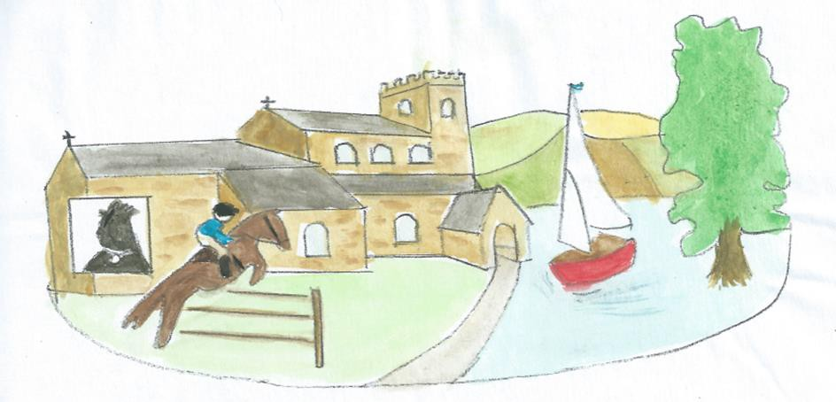
Saddington, a lovely village

